# Practical no. 03

# 3a) Aim :- Create a simple web page with various server controls to demonstrate setting and use of their properties , Create a Registration form to demonstrate use of various Validation controls.

**Home.aspx (Run this file): Design:**

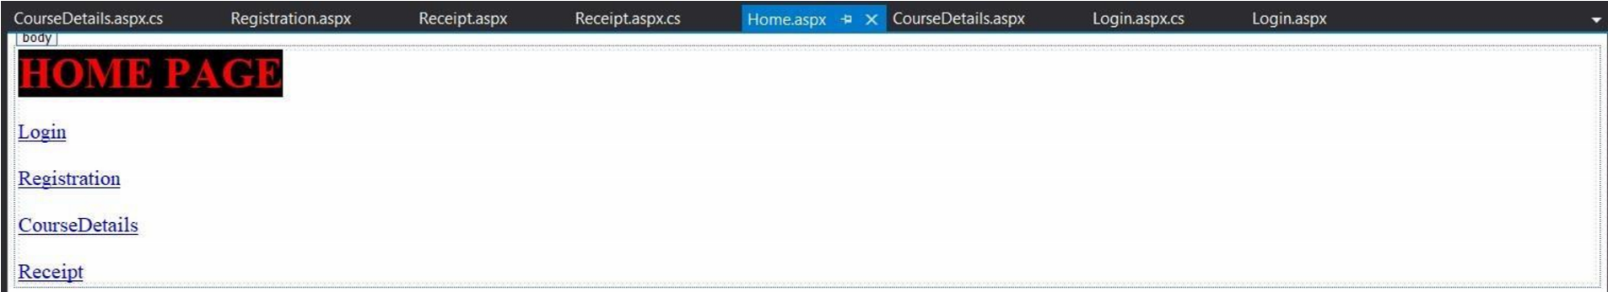

**Login.aspx Design:**

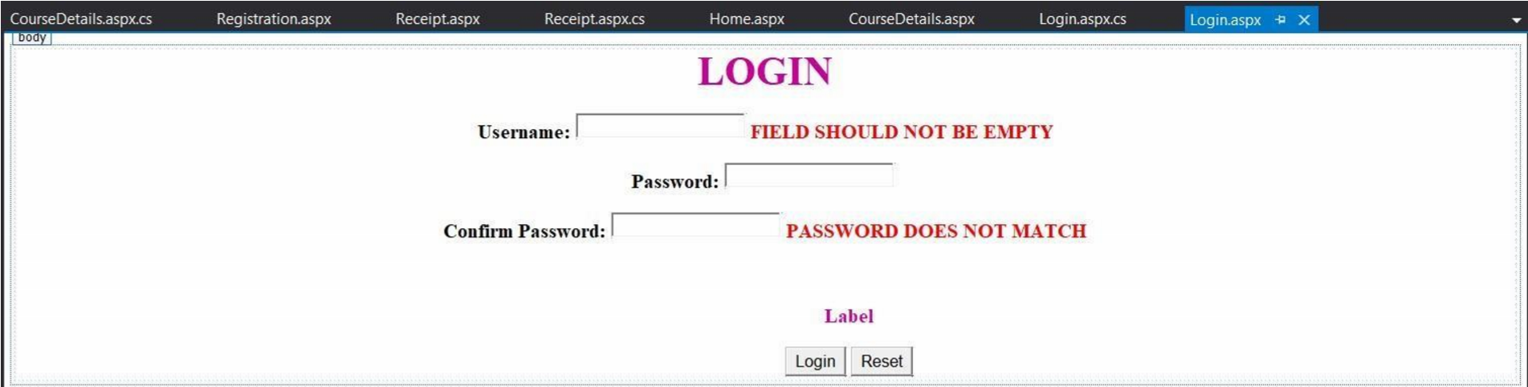

**Login.aspx.cs (Code behind):** using System;

using System.Collections.Generic;

using System.Web; using System.Web.UI;

using System.Web.UI.WebControls;

namespace validation

{ public partial class Login : System.Web.UI.Page

{ protected void Page_Load(object sender, EventArgs e)

{

} protected void btnlogin_Click(object sender, EventArgs e)

{ if (txtname.Text == "ABC" && txtpwd.Text == "123")

Response.Redirect("Registration.aspx");

else

Label1.Text = "Enter Invalid Information";

} protected void btnreset_Click(object sender, EventArgs e)

{ txtname.Text = ""; txtpwd.Text = ""; txtcnfpwd.Text = "";

}

}

}

**Registration.aspx Design:**

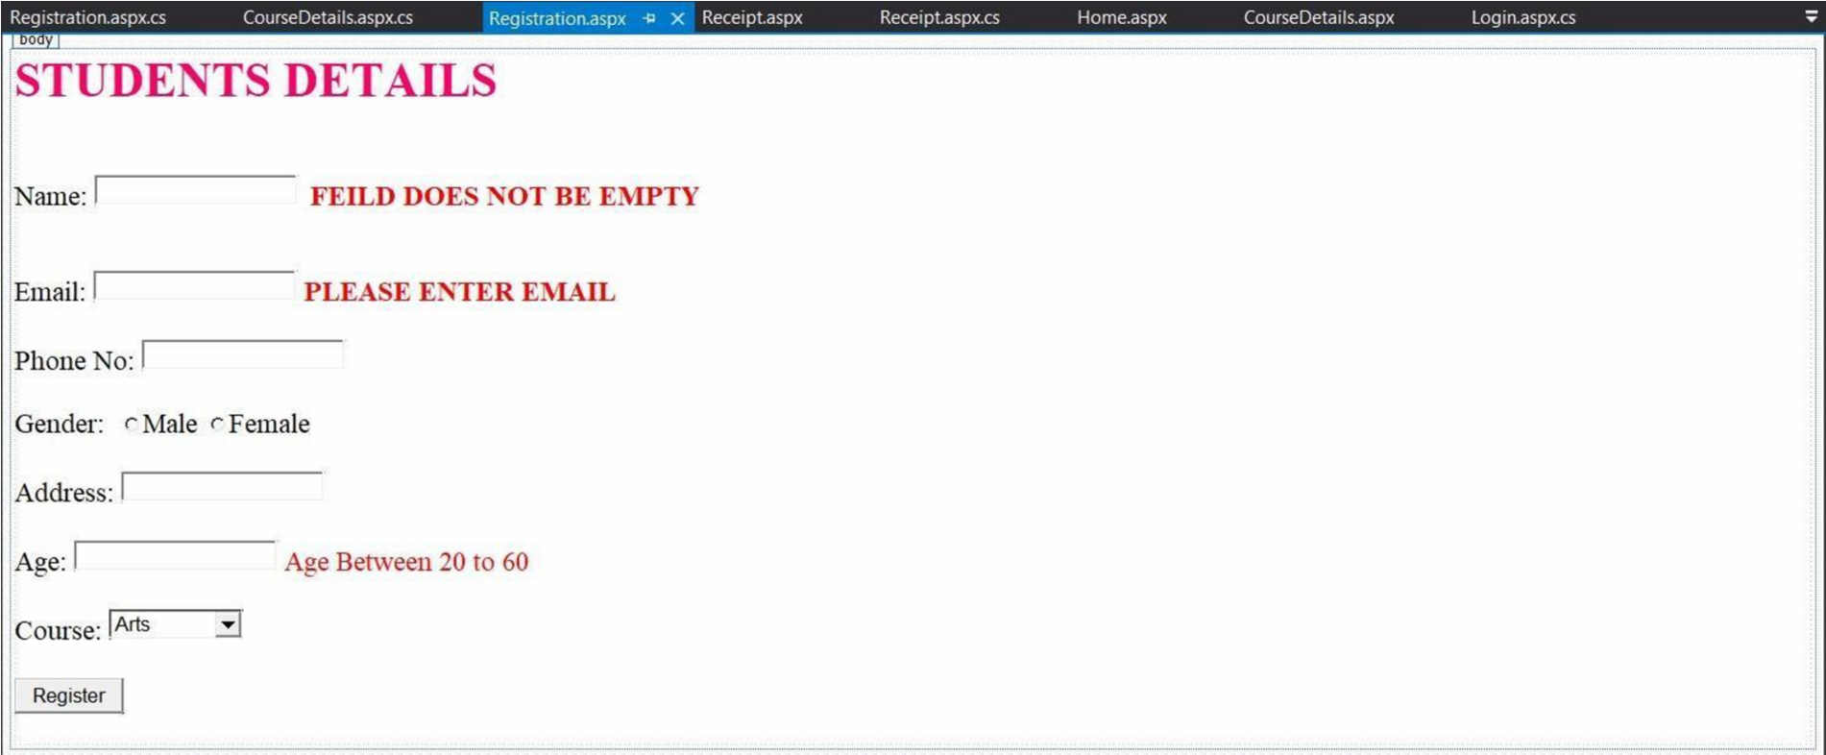

**Registration.aspx.cs (Code behind):**

using System;

using System.Collections.Generic;

using System.Web; using System.Web.UI;

using System.Web.UI.WebControls;

namespace validation

{ public partial class Registration : System.Web.UI.Page

{ protected void Page_Load(object sender, EventArgs e)

{

} protected void btnreg_Click(object sender, EventArgs e)

{ string g, c = " "; string[] a = new string[4];

if (RadioButton1.Checked == true) g = RadioButton1.Text;

else g = RadioButton2.Text;

if (DropDownList1.SelectedValue == "Arts") c = "10,000";

else if (DropDownList1.SelectedValue == "Science") c = "20,000";

else if (DropDownList1.SelectedValue == "Commerce") c = "45,000";

Response.Redirect("Receipt.aspx?Name=" + TextBox1.Text + "&Gender=" + g + "&Email=" +

TextBox2.Text + "&Course=" + DropDownList1.SelectedValue + "&Fees=" + c);

}

}

}

**CourseDetails.aspx Design:**

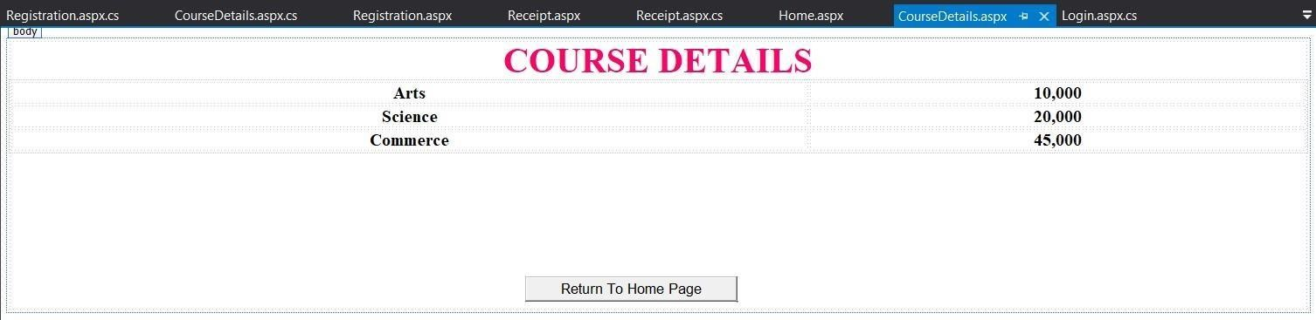

**CourseDetails.aspx.cs (Code behind):**

using System;

using System.Collections.Generic;

using System.Web; using System.Web.UI;

using System.Web.UI.WebControls;

namespace validation

{

public partial class CourseDetails : System.Web.UI.Page

{ protected void Page_Load(object sender, EventArgs e)

{

} protected void Button1_Click(object sender, EventArgs e)

{

Response.Redirect("Home.aspx"); }

}

}

**Receipt.aspx Design:**

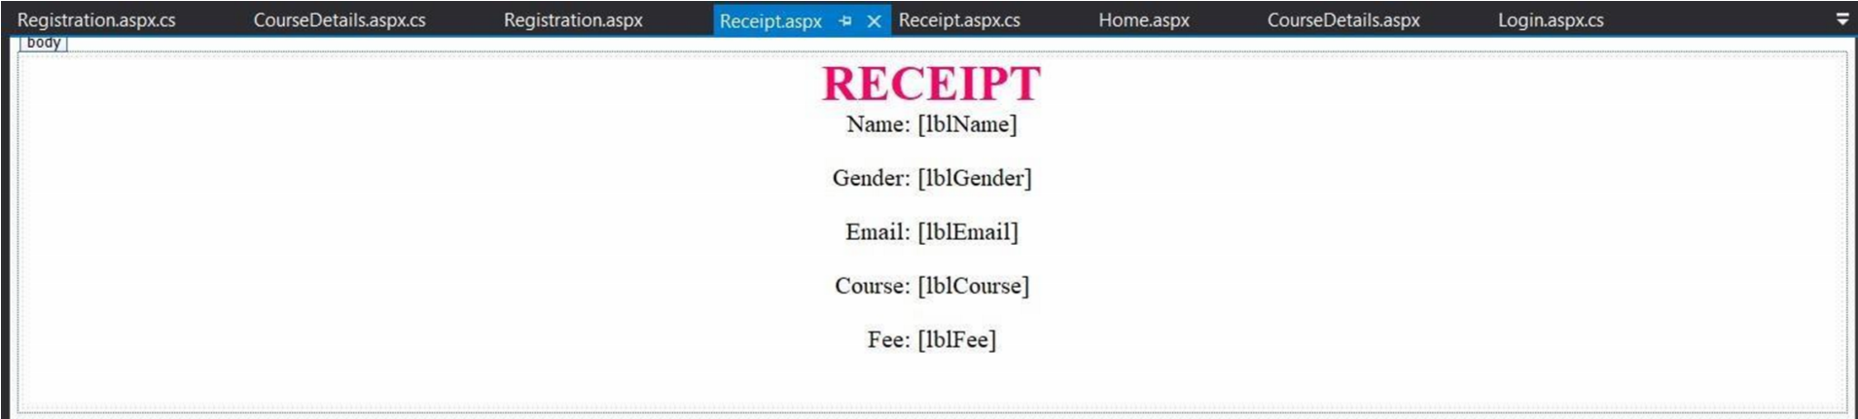

**Receipt.aspx.cs (Code behind):** using System;

using System.Collections.Generic;

using System.Web; using System.Web.UI;

using System.Web.UI.WebControls;

namespace validation

{ public partial class Receipt : System.Web.UI.Page

{ protected void Page_Load(object sender, EventArgs e)

{ lblName.Text = Request.QueryString["Name"]; lblGender.Text = Request.QueryString["Gender"]; lblEmail.Text = Request.QueryString["Email"]; lblCourse.Text = Request.QueryString["Course"]; lblFee.Text = Request.QueryString["Fees"];

}

}

}

**Outputs :-**

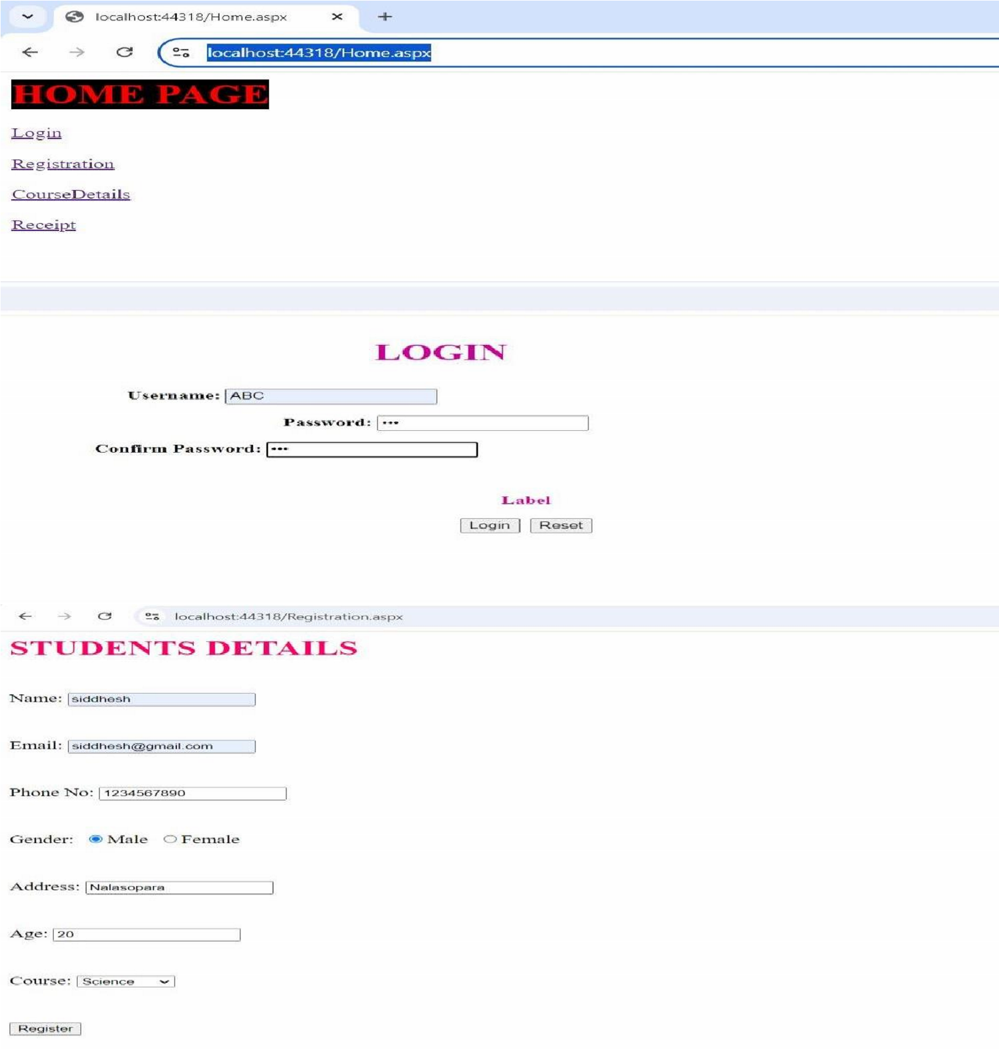

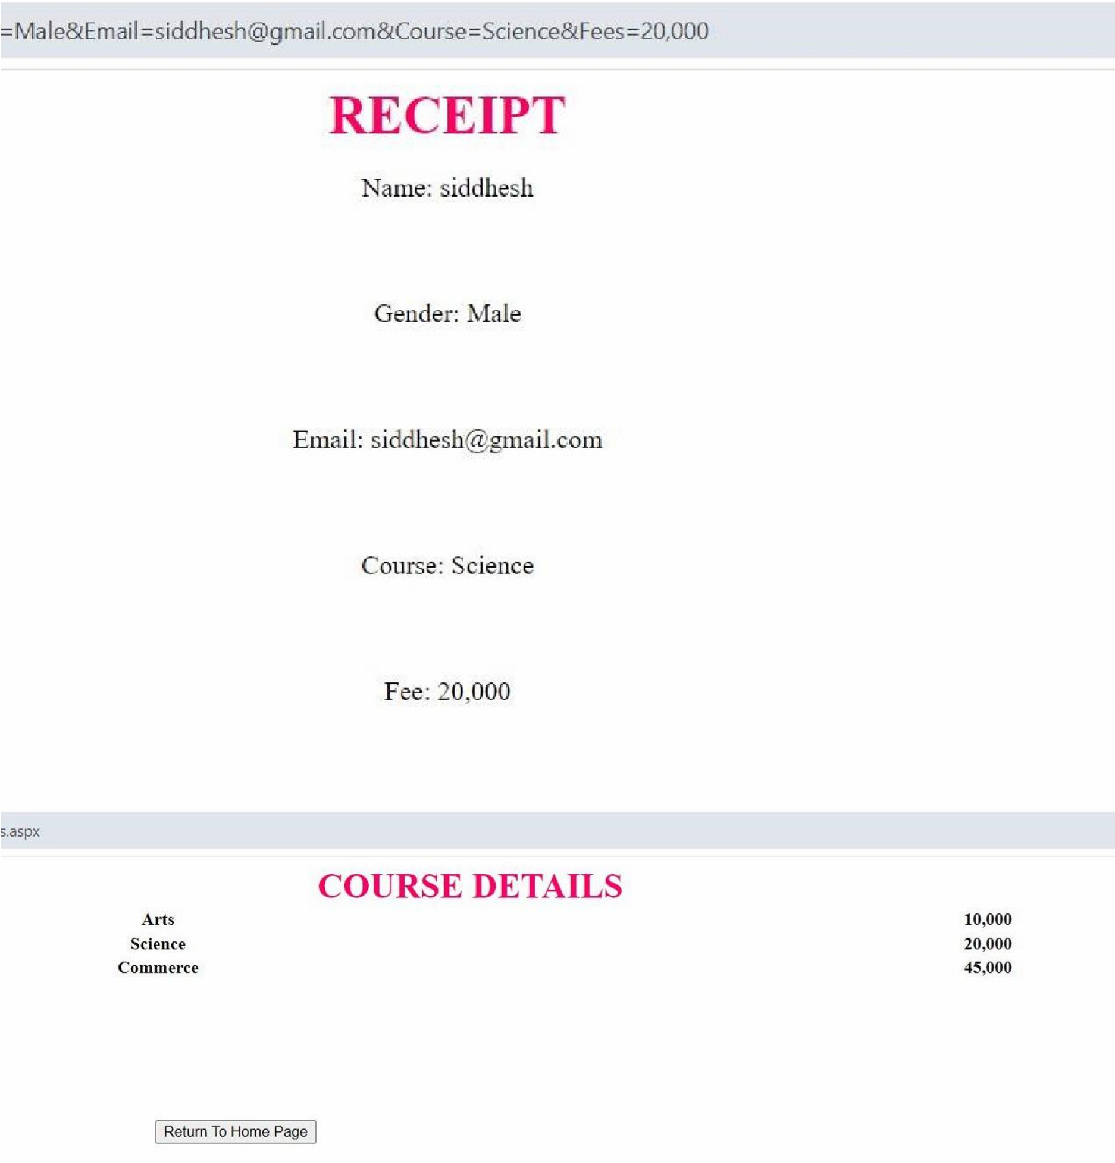

# 3b) Aim :- Create a simple application to demonstrate your vacation using calendar control.

**CalendarCtrl.aspx Design:**

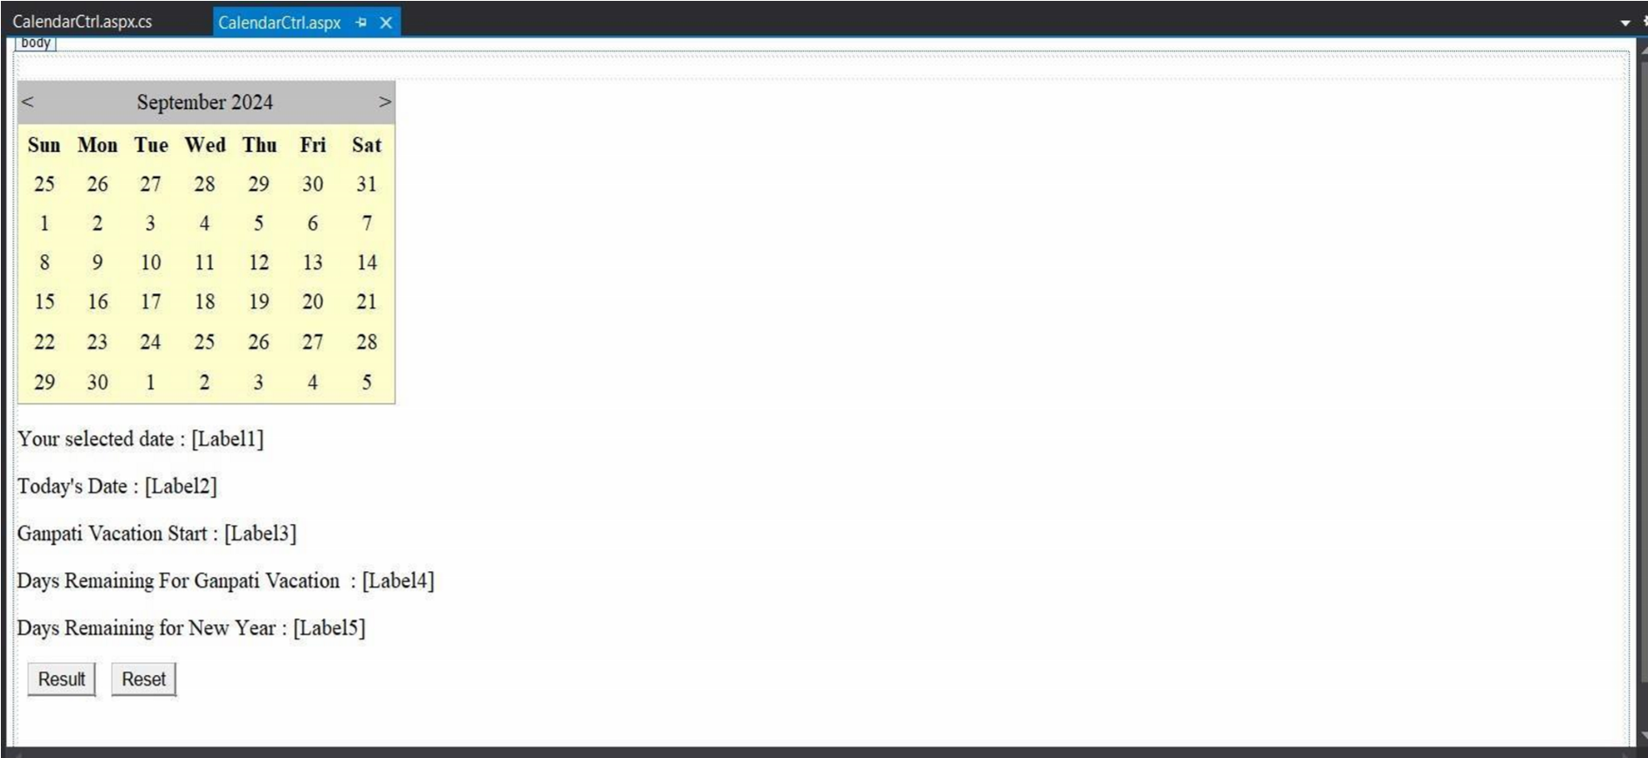

**CalendarCtrl.aspx.cs (Code behind):**

using System;

using System.Collections.Generic; using System.Linq; using System.Web; using System.Web.UI;

using System.Web.UI.WebControls;

namespace calendar

{ public partial class CalendarCtrl : System.Web.UI.Page

{ protected void Page_Load(object sender, EventArgs e)

{

} protected void Calendar1_DayRender(object sender, DayRenderEventArgs e)

{ if(e.Day.Date.Day == 5 && e.Day.Date.Month == 9)

{

e.Cell.BackColor = System.Drawing.Color.Yellow;

Label lb1 = new Label();

lb1.Text = "<br>Teachers Day!";

e.Cell.Controls.Add(lb1); Image g1 = new Image(); g1.ImageUrl = "td.jpg"; g1.Height = 25; g1.Width = 25;

e.Cell.Controls.Add(g1); }

if(e.Day.Date.Day == 7 && e.Day.Date.Month == 9)

{

e.Cell.BackColor = System.Drawing.Color.Yellow;

Calendar1.SelectedDate = new DateTime(2024, 9, 7);

Calendar1.SelectedDates.SelectRange(Calendar1.SelectedDate,

Calendar1.SelectedDate.AddDays(10)); Label lbl1 = new Label(); lbl1.Text = "<br>Ganpati!";

e.Cell.Controls.Add(lbl1); Image p1 = new Image(); p1.ImageUrl = "gapati.jfif"; p1.Height = 25;

p1.Width = 25;

e.Cell.Controls.Add(p1);

}

} protected void btnResult_Click(object sender, EventArgs e)

{

Calendar1.Caption = "SAMBARE";

Calendar1.FirstDayOfWeek = FirstDayOfWeek.Sunday;

Calendar1.NextPrevFormat = NextPrevFormat.ShortMonth;

Calendar1.TitleFormat = TitleFormat.Month;

Label2.Text = Calendar1.TodaysDate.ToShortDateString(); Label3.Text = "9-7-2024";

TimeSpan d = new DateTime(2024, 9, 7) - DateTime.Now;

Label4.Text = d.Days.ToString();

TimeSpan d1 = new DateTime(2024, 12, 31) - DateTime.Now;

Label5.Text = d1.Days.ToString();

if (Calendar1.SelectedDate.ToShortDateString() == "9-7-2024")

Label3.Text = "<b>Ganpati Festival Start</b>"; if (Calendar1.SelectedDate.ToShortDateString() == "9-17-2024")

Label3.Text = "<b>Ganpati Festival End</b>";

} protected void btnReset_Click(object sender, EventArgs e)

{

Label1.Text = ""; Label2.Text = "";

Label3.Text = "";

Label4.Text = "";

Label5.Text = "";

Calendar1.SelectedDates.Clear();

} protected void Calendar1_SelectionChanged(object sender, EventArgs e)

{

Label1.Text = Calendar1.SelectedDate.ToString(); }

} }

**Output :-**

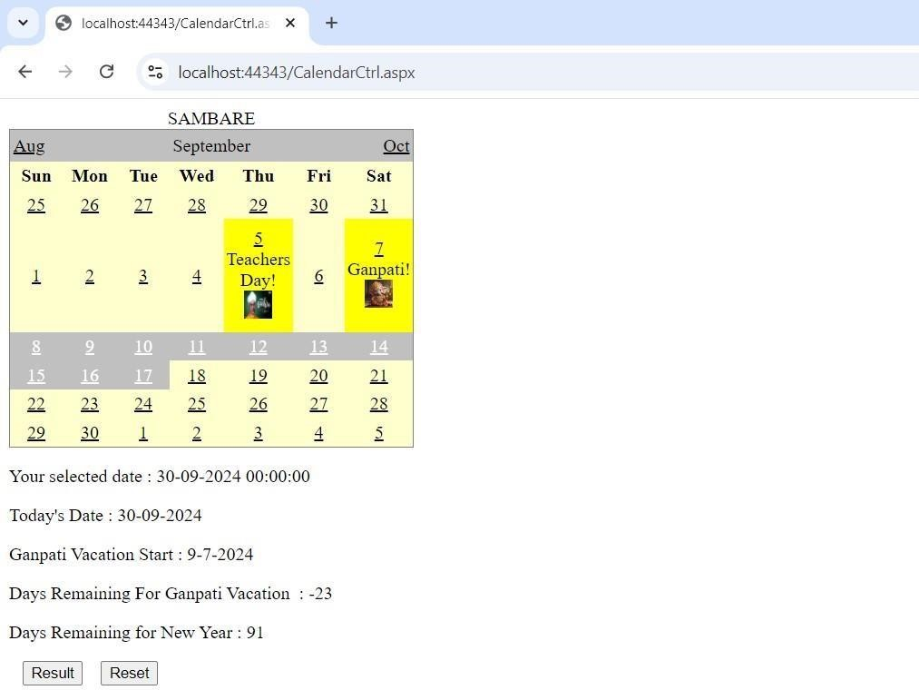

# 3c) Aim :- Demonstrate the use of Treeview operations on the web form.

**WebForm.aspx**

**Design:**

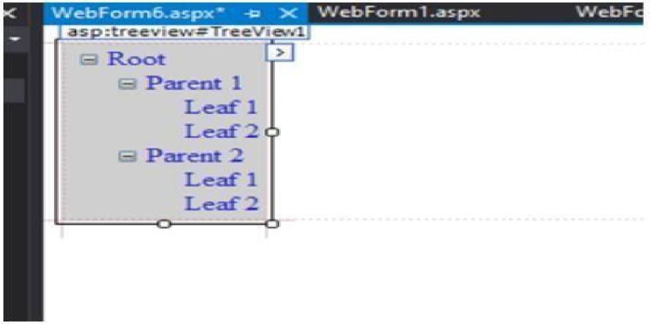

**Adding nodes & its properties:**

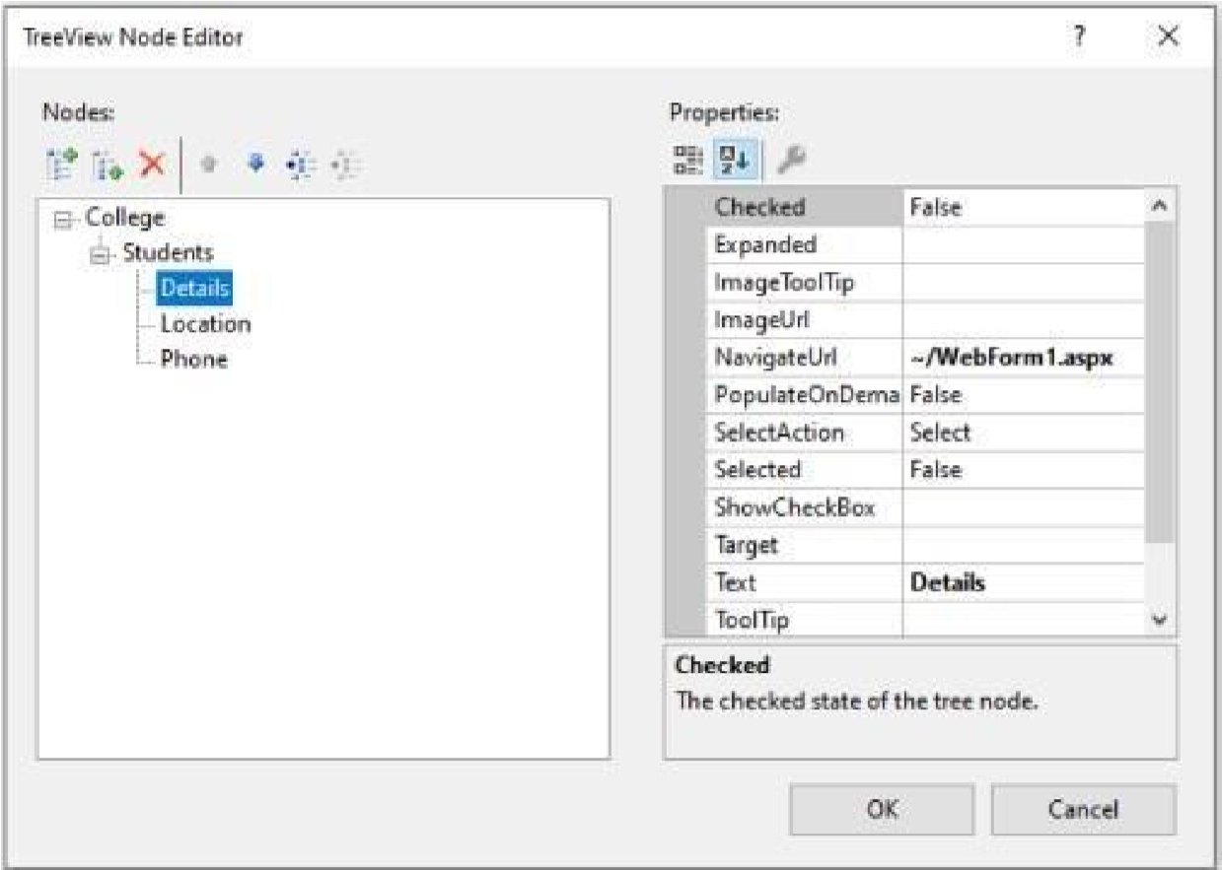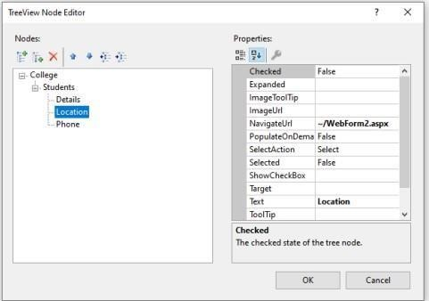

**WebForm.aspx**

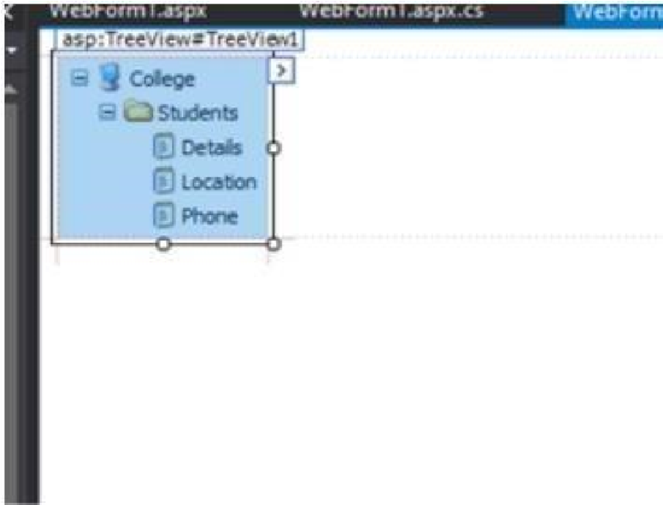

**Output :-**

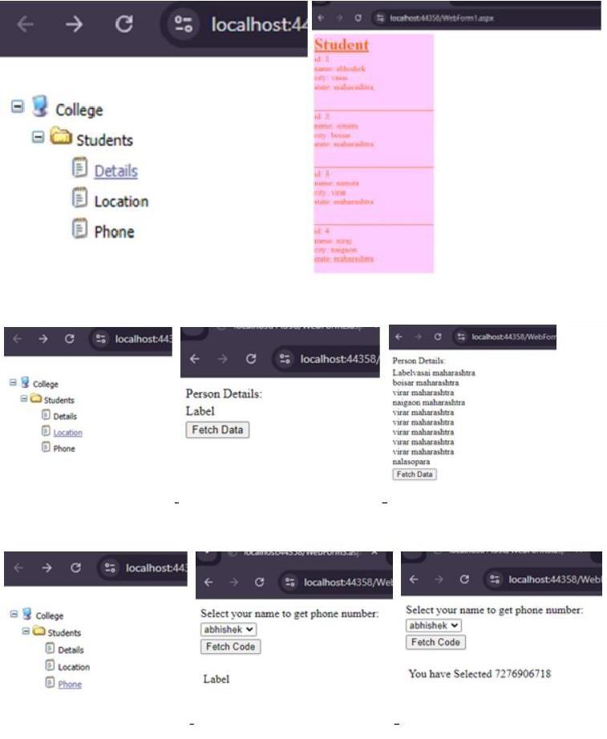

# 3d) Aim :- Demonstrate the use of DataList operations on the web form.

**WebForm.aspx**

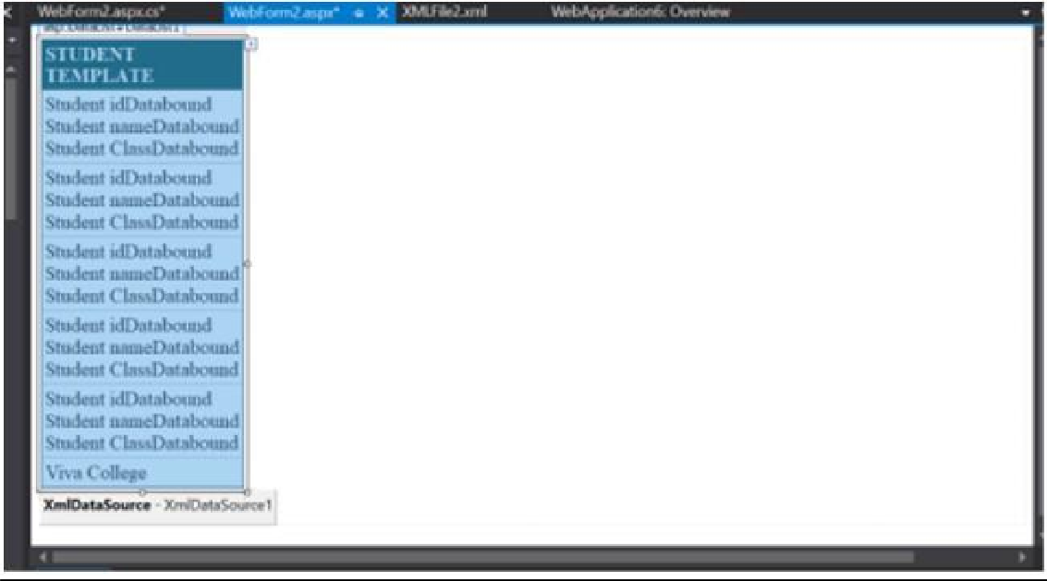

**XMLFile.xml**

<?xml version="1.0" encoding="utf-8" ?> < Studentdetail>

<student>

<sid>1</sid>

< sname>Abhishek</sname>

<sclass>TYIT</sclass>

</student> <student>

<sid>2</sid>

<sname>Sonam</sname>

<sclass>TYIT</sclass>

</student> <student>

<sid>3</sid>

< sname>Namita</sname>

< sclass>TYIT</sclass>

< /student> < student>

< sid>4</sid>

< sname>Niraj</sname>

< sclass>TYIT</sclass>

< /student> < student>

<sid>5</sid>

< sname>Shruti</sname>

< sclass>TYIT</sclass>

< /student>

< /Studentdetail>

**WebForm.aspx.cs** using System;

using System.Data; using System.Collections.Generic; using System.Linq; using System.Web; using System.Web.UI; using System.Web.UI.WebControls; namespace

WebApplication6

{ public partial class WebForm2 : System.Web.UI.Page

{

protected void Page_Load(object sender, EventArgs e)

{ if (!IsPostBack)

{

BindData();

}

} protected void BindData()

{

DataSet ds = new DataSet(); ds.ReadXml(Server.MapPath("XMLFile2.xml")); if (ds != null && ds.HasChanges())

{

DataList1.DataSource = ds;

DataList1.DataBind(); }

else

{

DataList1.DataBind();

}

}

}

}

**Output :-**

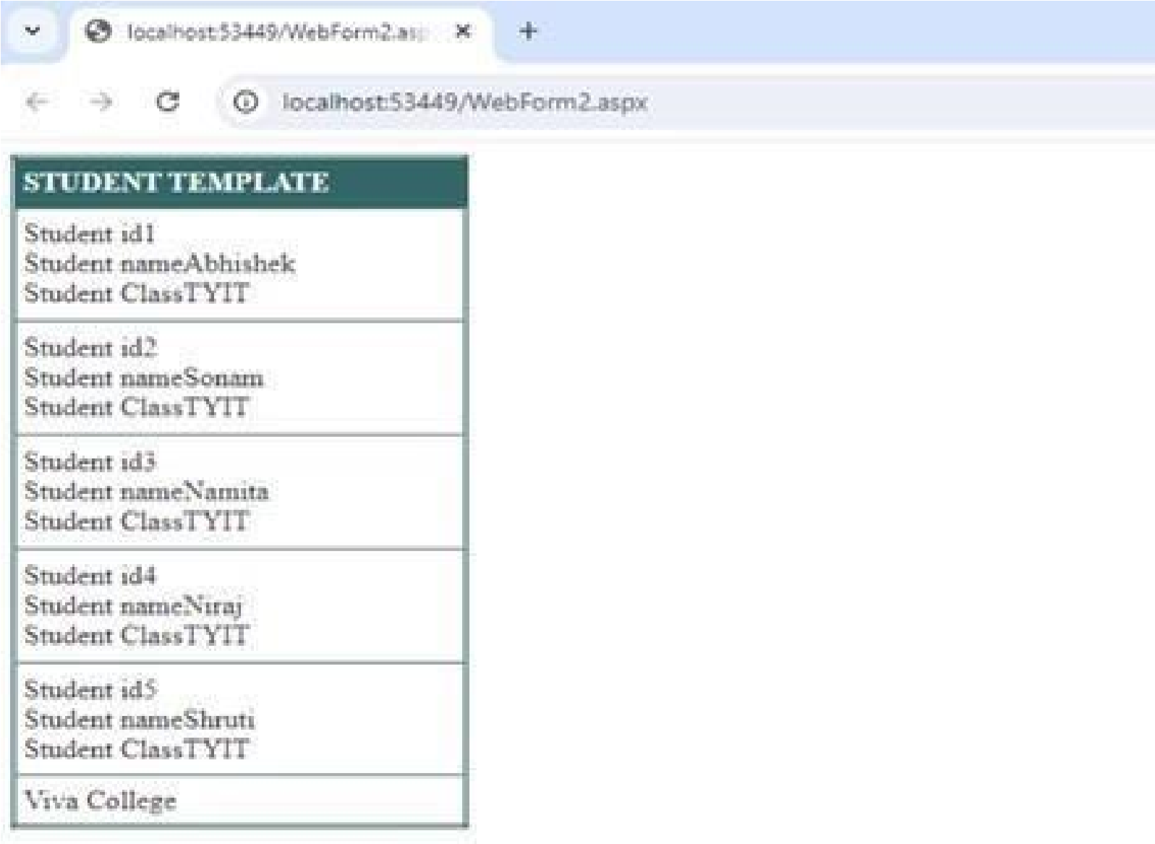

# Practical no. 04

# 4a) Aim :- Create Web Form to demonstrate use of Adrotator Control.

**ad.aspx Design:**

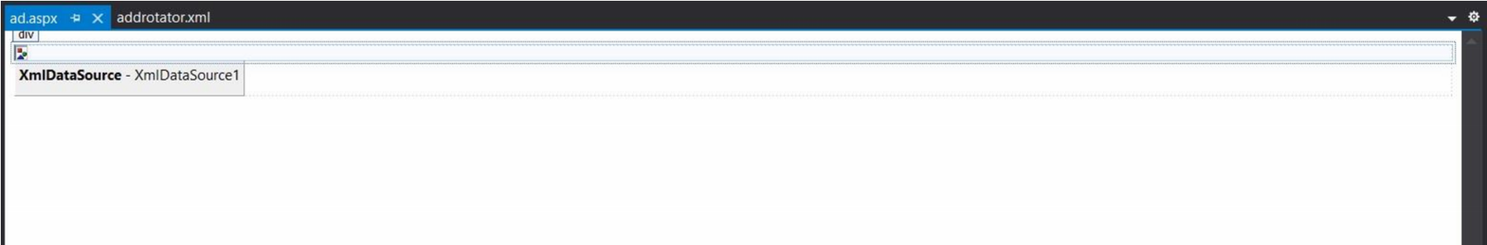

**addrotator.xml**

<?xml version="1.0" encoding="utf-8" ?>

<Advertisements>

<Ad>

<ImageUrl>rose.jfif</ImageUrl>

<NavigateUrl>https[://www.](http://www.1800flowers.com/)18[00flowers.com<](http://www.1800flowers.com/)/NavigateUrl>

<AlternateText>

Order flowers, roses, gifts and more

</AlternateText>

<Impressions>20</Impressions>

<Keyword>flowers</Keyword>

</Ad>

<Ad>

<ImageUrl>lotus.jfif</ImageUrl>

<NavigateUrl>https[://www.flowerzila.com](http://www.flowerzila.com/)</NavigateUrl>

<AlternateText>

Order flowers, roses and more

</AlternateText>

<Impressions>20</Impressions>

<Keyword>russia</Keyword>

</Ad>

<Ad>

<ImageUrl>lily.jfif</ImageUrl>

<NavigateUrl>https://poki.com</NavigateUrl>

<AlternateText>

Order flowers, roses and more

</AlternateText>

<Impressions>20</Impressions>

<Keyword>russia</Keyword>

</Ad>

<Ad>

<ImageUrl>peri.jfif</ImageUrl>

<NavigateUrl>https[://www.swiggy.com<](http://www.swiggy.com/)/NavigateUrl>

<AlternateText>

Order flowers, roses and more

</AlternateText>

<Impressions>20</Impressions>

<Keyword>russia</Keyword>

</Ad>

<Ad>

<ImageUrl>sunflower.jfif</ImageUrl>

<NavigateUrl>https[://www.](http://www.easemytrip.com/)ea[semytrip.com<](http://www.easemytrip.com/)/NavigateUrl>

<AlternateText>

Order flowers, roses and more

</AlternateText>

<Impressions>20</Impressions>

<Keyword>russia</Keyword>

</Ad>

</Advertisements>

**Output :-**

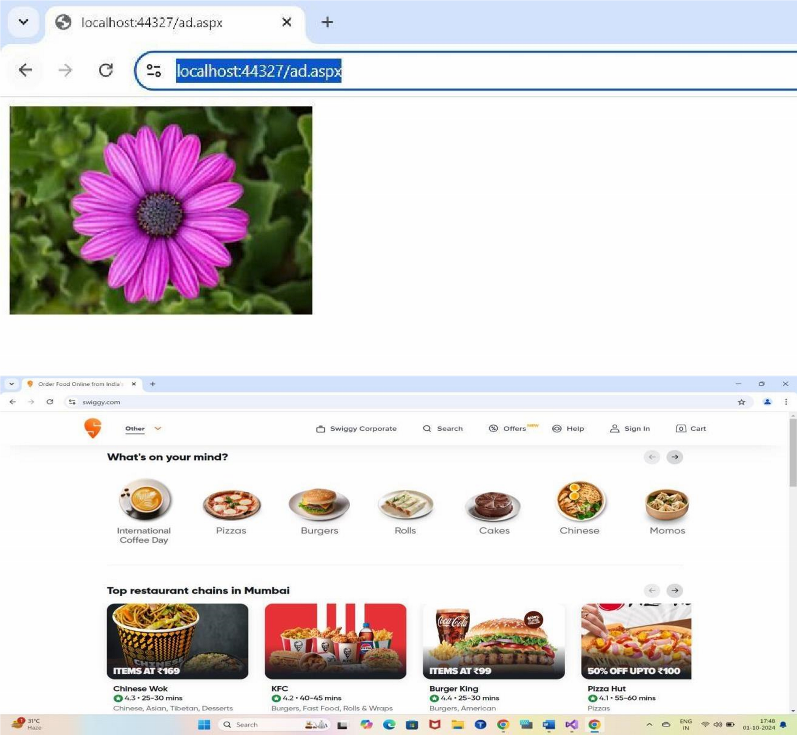

# 4b) Aim :- Create Web Form to demonstrate use User Controls

**MyUersControl.aspx (Run this): Design:**

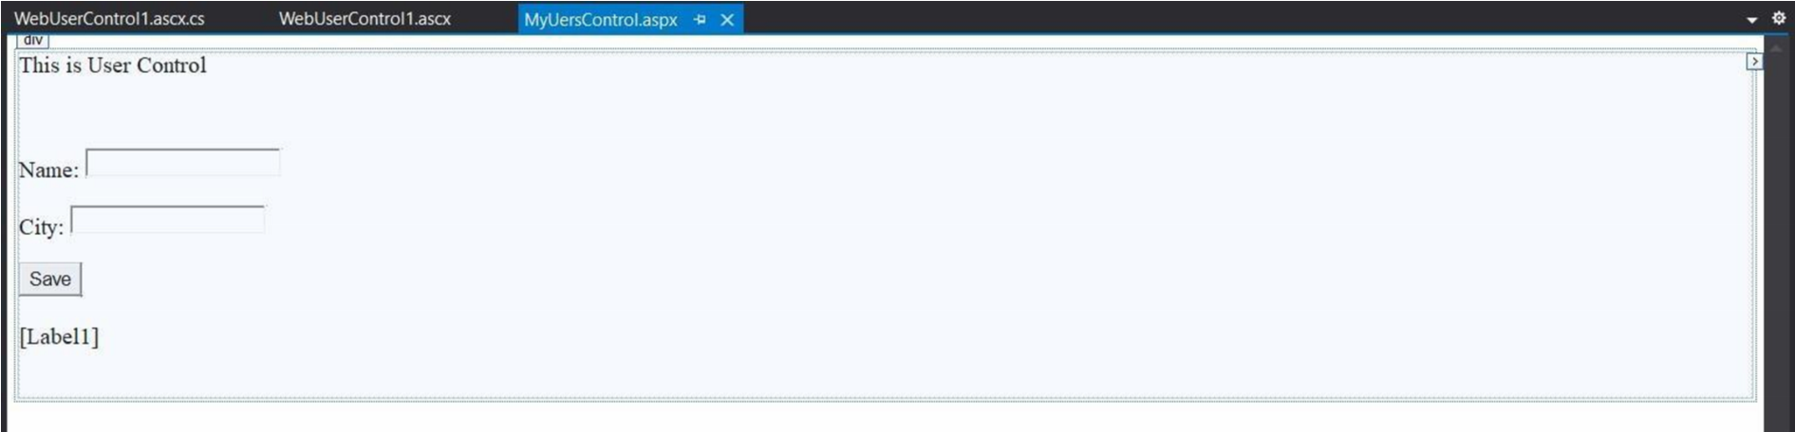

**WebUserControl1.ascx (User Control): Design:**

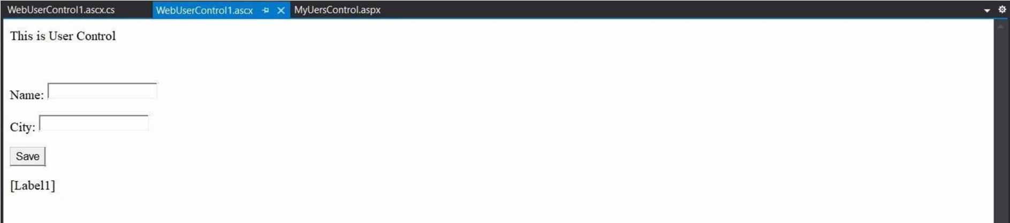

**WebUserControl1.ascx.cs (Code behind):**

using System;

using System.Collections.Generic; using System.Web; using System.Web.UI; using System.Web.UI.WebControls; namespace UserControl

{ public partial class WebUserControl1 : System.Web.UI.UserControl

{ protected void Page_Load(object sender, EventArgs e)

{

}

protected void txtBtn_Click(object sender, EventArgs e)

{

Label1.Text = "Your Name is " + txtName.Text + " and you are from " + txtCity.Text;

}

}

}

**Output :-**

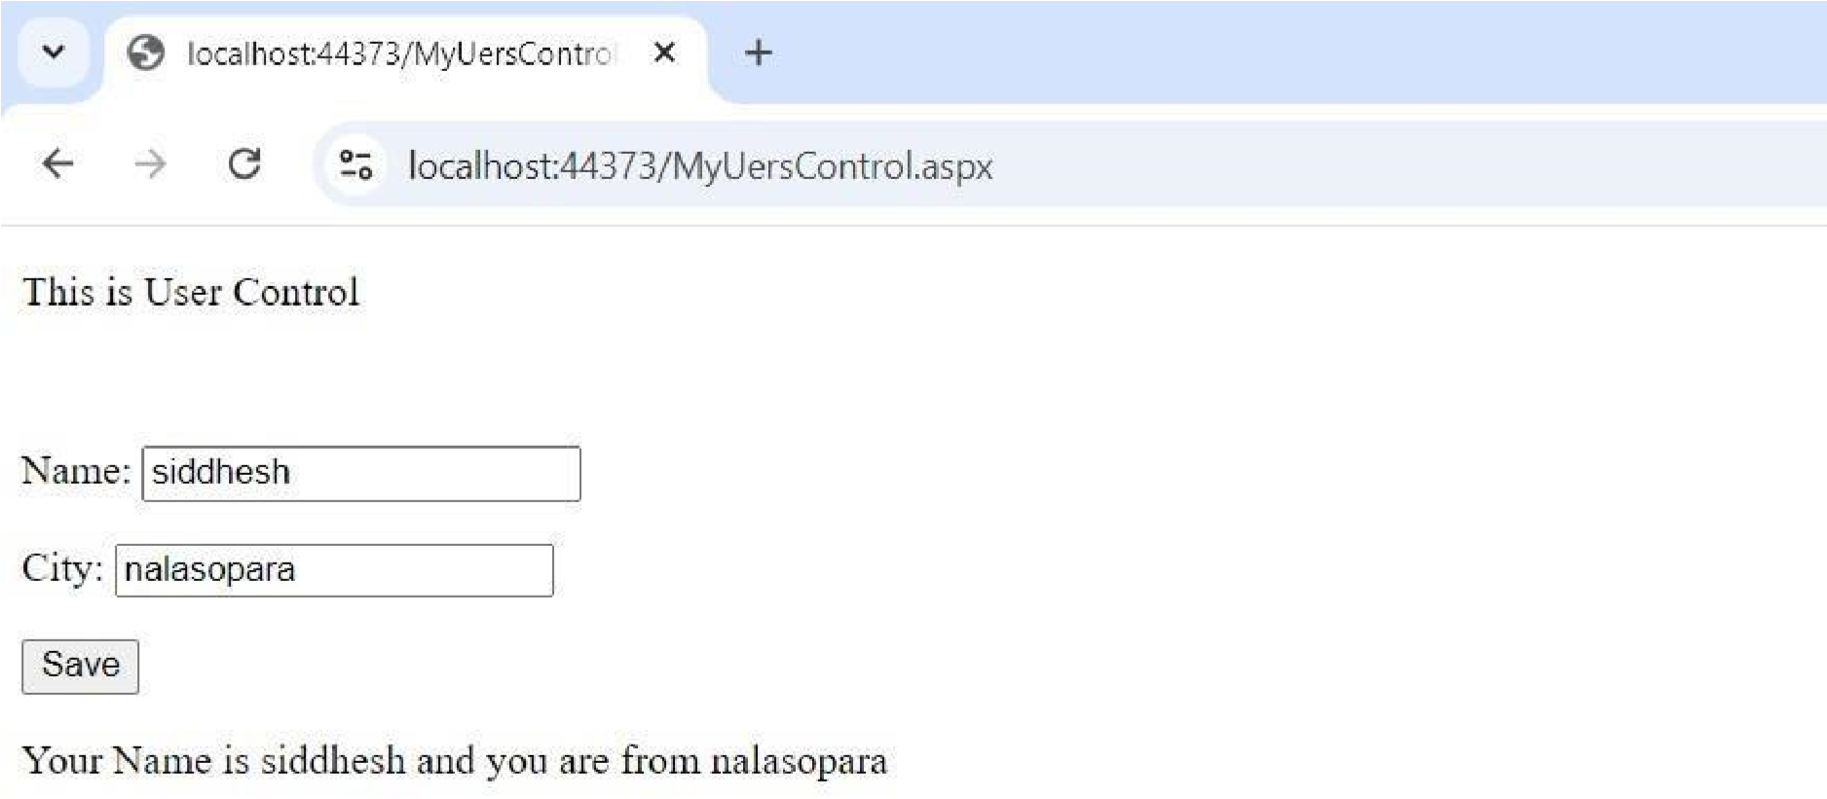

# Practical no. 05

# 5a) Aim :- Create a web application to demonstrate the use of session

**session1.aspx Design:**

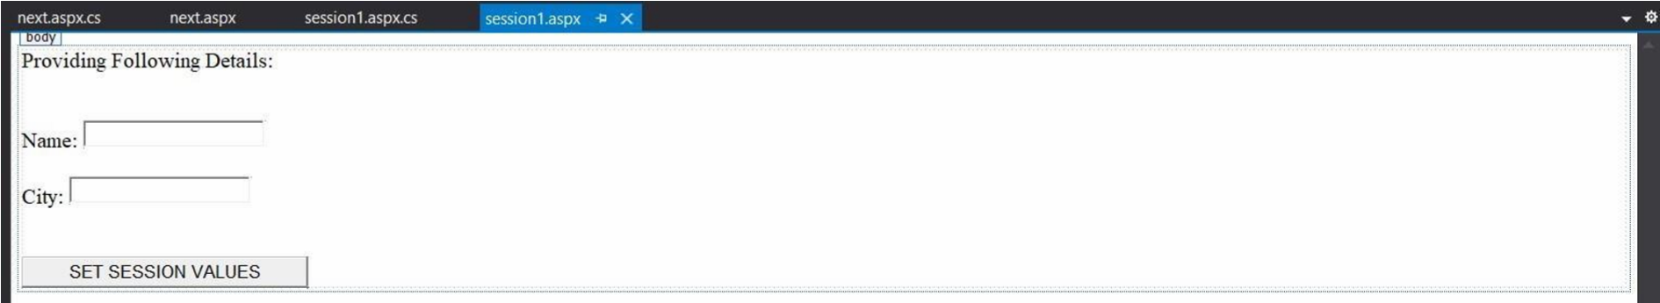

**session1.aspx.cs (Code behind):** using System; using System.Collections.Generic; using System.Web; using System.Web.UI; using System.Web.UI.WebControls; namespace session

{

public partial class session1 : System.Web.UI.Page

{

protected void Page_Load(object sender, EventArgs e)

{

}

protected void getbtn_Click(object sender, EventArgs e)

{

Session["name"] = name.Text;

Session["city"] = city.Text;

Response.Redirect("next.aspx");

}

}

}

**next.aspx Design:**

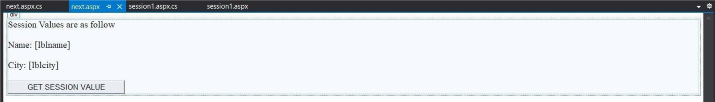

**next.aspx.cs (Code behind):** using System;

using System.Collections.Generic; using System.Web; using System.Web.UI; using System.Web.UI.WebControls; namespace session

{ public partial class next : System.Web.UI.Page

{ protected void Page_Load(object sender, EventArgs e)

{

}

protected void Button1_Click(object sender, EventArgs e)

{ lblname.Text = Session["name"].ToString();

lblcity.Text = Session["city"].ToString(); }

} }

**Output :-**

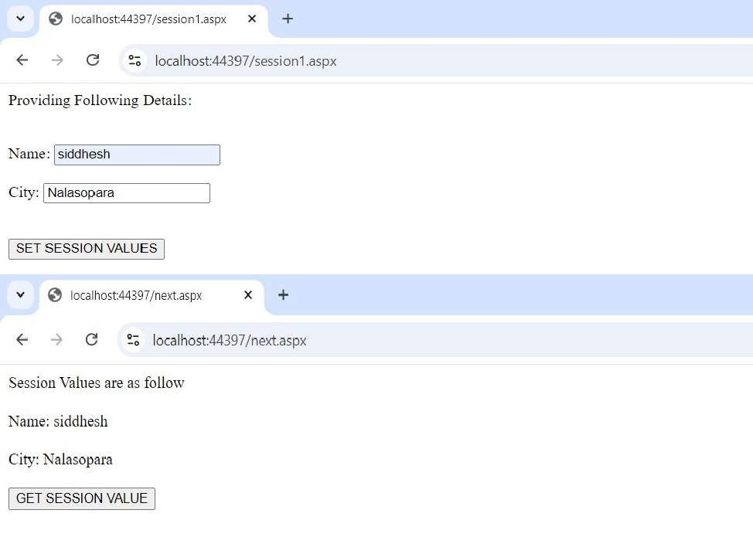

**Practical no. 06**

# 6a) Aim :- Multiline Textbox for Query Processing.

**dbo.Student**

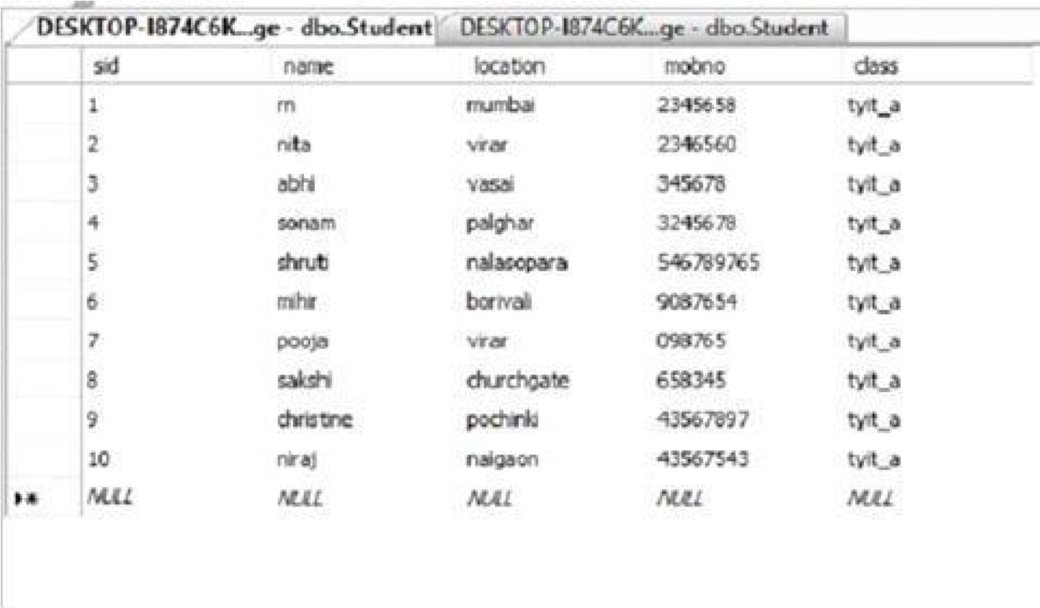

**WebForm.aspx**

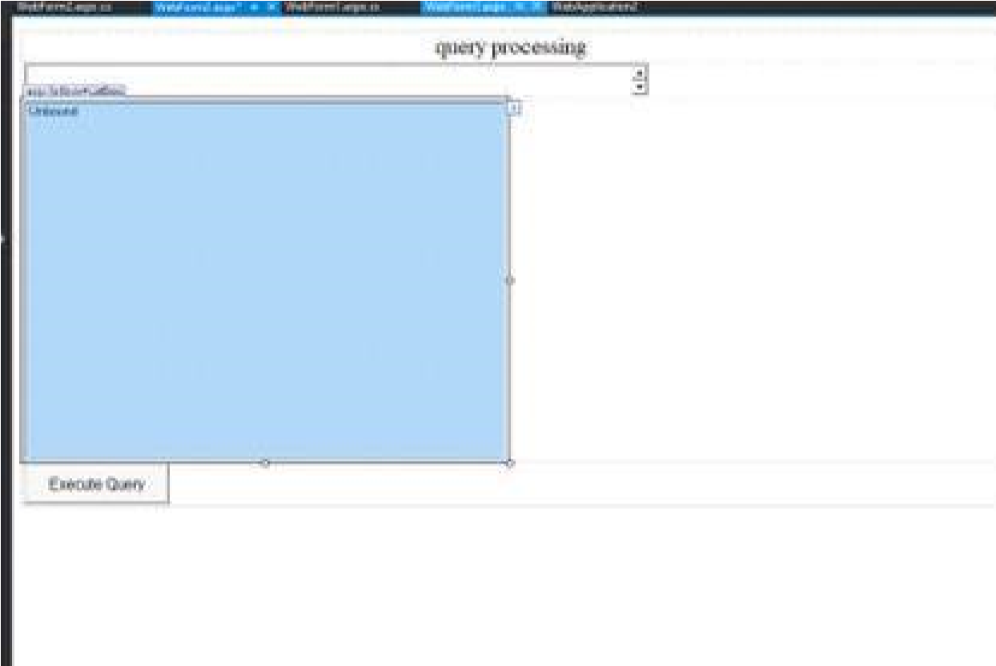

**Connecting to Sql Database**

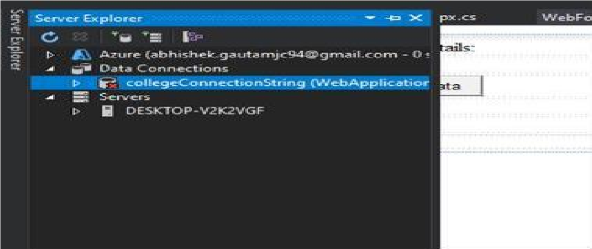

**Testing Connection**

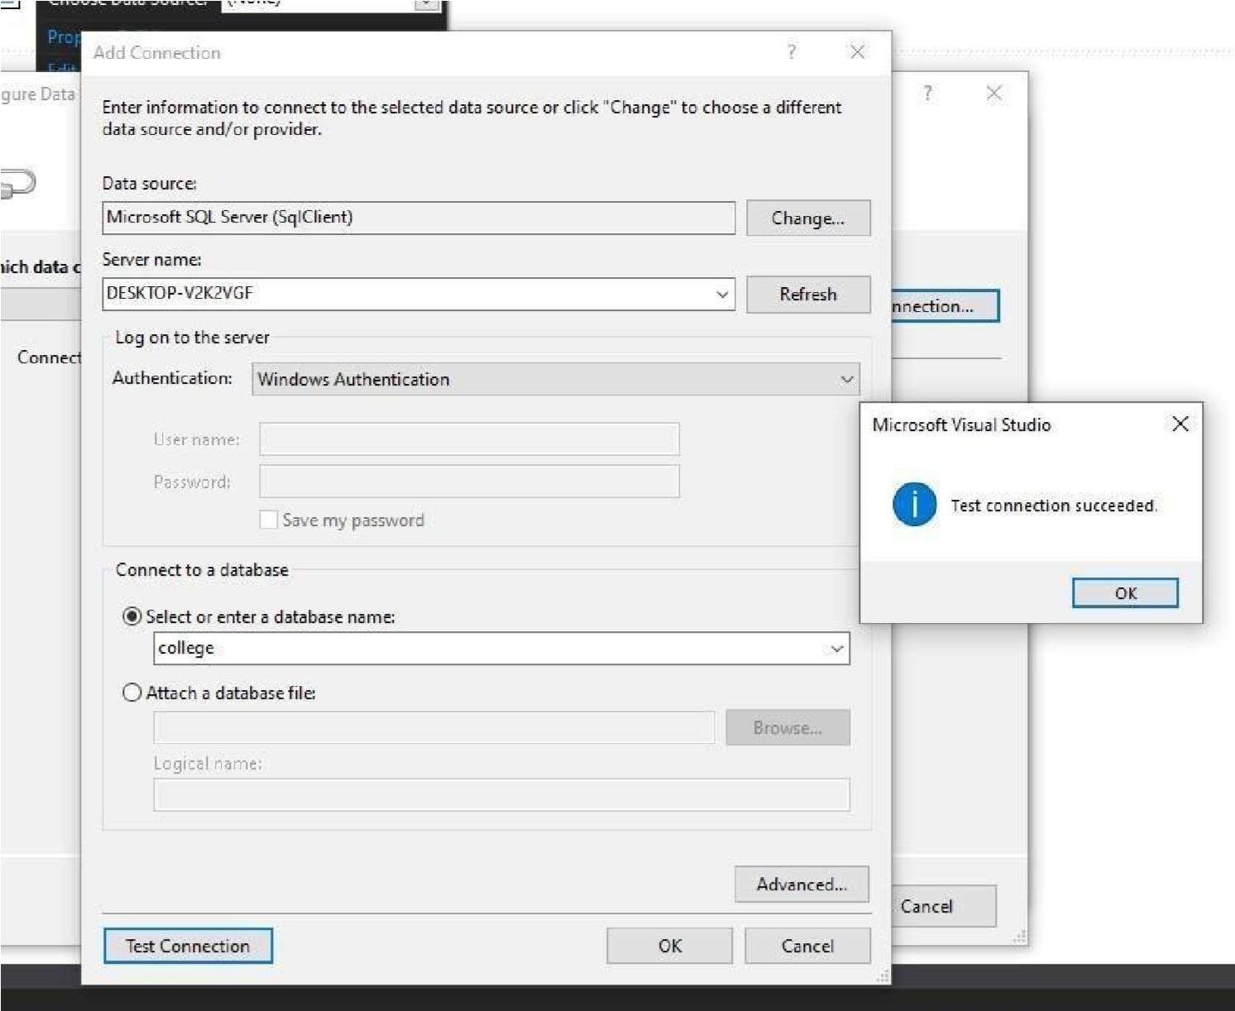

**WebForm.aspx.cs** using System; using System.Data.SqlClient; using System.Collections.Generic; using System.Linq; using System.Web; using System.Web.UI; using System.Web.UI.WebControls; namespace WebApplication2

{ public partial class WebForm2 : System.Web.UI.Page

{

protected void Page_Load(object sender, EventArgs e)

{ }

protected void Button1_Click(object sender, EventArgs e)

{

SqlConnection conn = new SqlConnection("Data Source=.;Initial Catalog=college;Integrated Security=True"); conn.Open();

SqlCommand cmd = new SqlCommand(TextBox1.Text, conn);

SqlDataReader dr = cmd.ExecuteReader();

ListBox1.Items.Clear();

while (dr.Read())

{

for (int i = 0; i <= dr.FieldCount - 1; i++)

{

ListBox1.Items.Add(dr[i].ToString()); }

}

}

}

}

**Output :-**

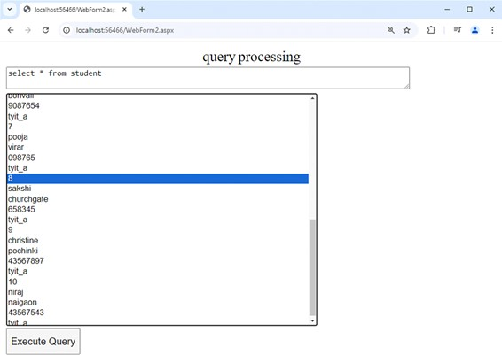

# 6b) Aim :- Displaying record from Database.

**dbo.Table_1**

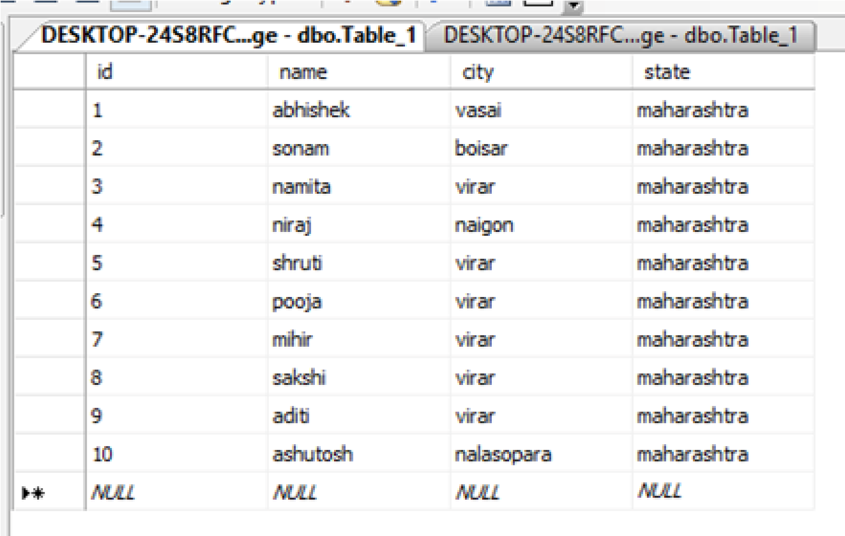

**Webform.aspx**

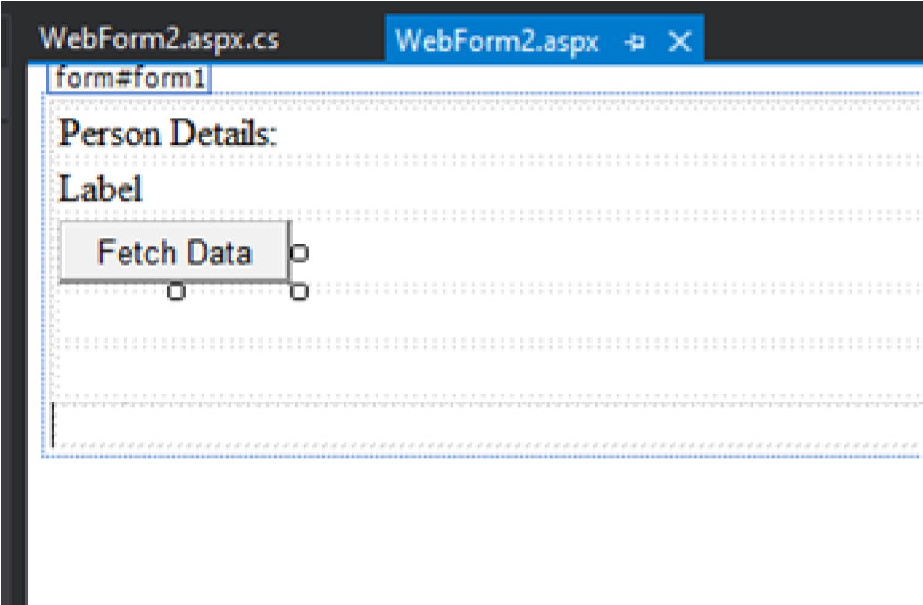

**Webform.aspx.cs** using System; using

System.Collections.Generic; using

System.Data.SqlClient;

using System.Linq; using System.Web; using System.Web.UI;

using System.Web.UI.WebControls;

namespace WebApplication10

{

public partial class WebForm2 : System.Web.UI.Page {

protected void Page_Load( object sender, EventArgs e)

{

} protected void Button1_Click( object sender, EventArgs e)

{

SqlConnection conn = new SqlConnection( "Data Source=.;Initial

Catalog=College;Integrated Security=True" ) ; conn.Open();

SqlCommand cmd = new SqlCommand( "select city,state from Table_1",conn);

SqlDataReader dr = cmd.ExecuteReader();

while( dr.Read())

{

Label1.Text += dr[ "city" ] .ToString() + " " + dr[ "state" ]

.ToString() + "<br>" ;

} dr.Close();

conn.Close();

}

}

}

**Output :-**

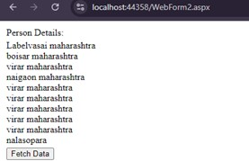

# Practical no. 07

# 7a) Aim :- Demonstrate use of Datalist link control.

**WebForm.aspx**

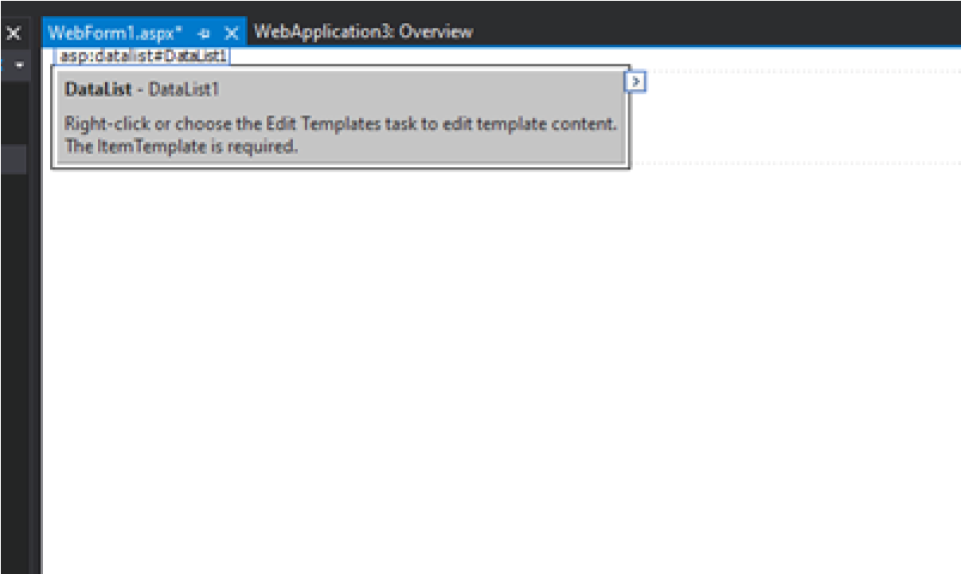

**Connecting Datalist to Sql Database**

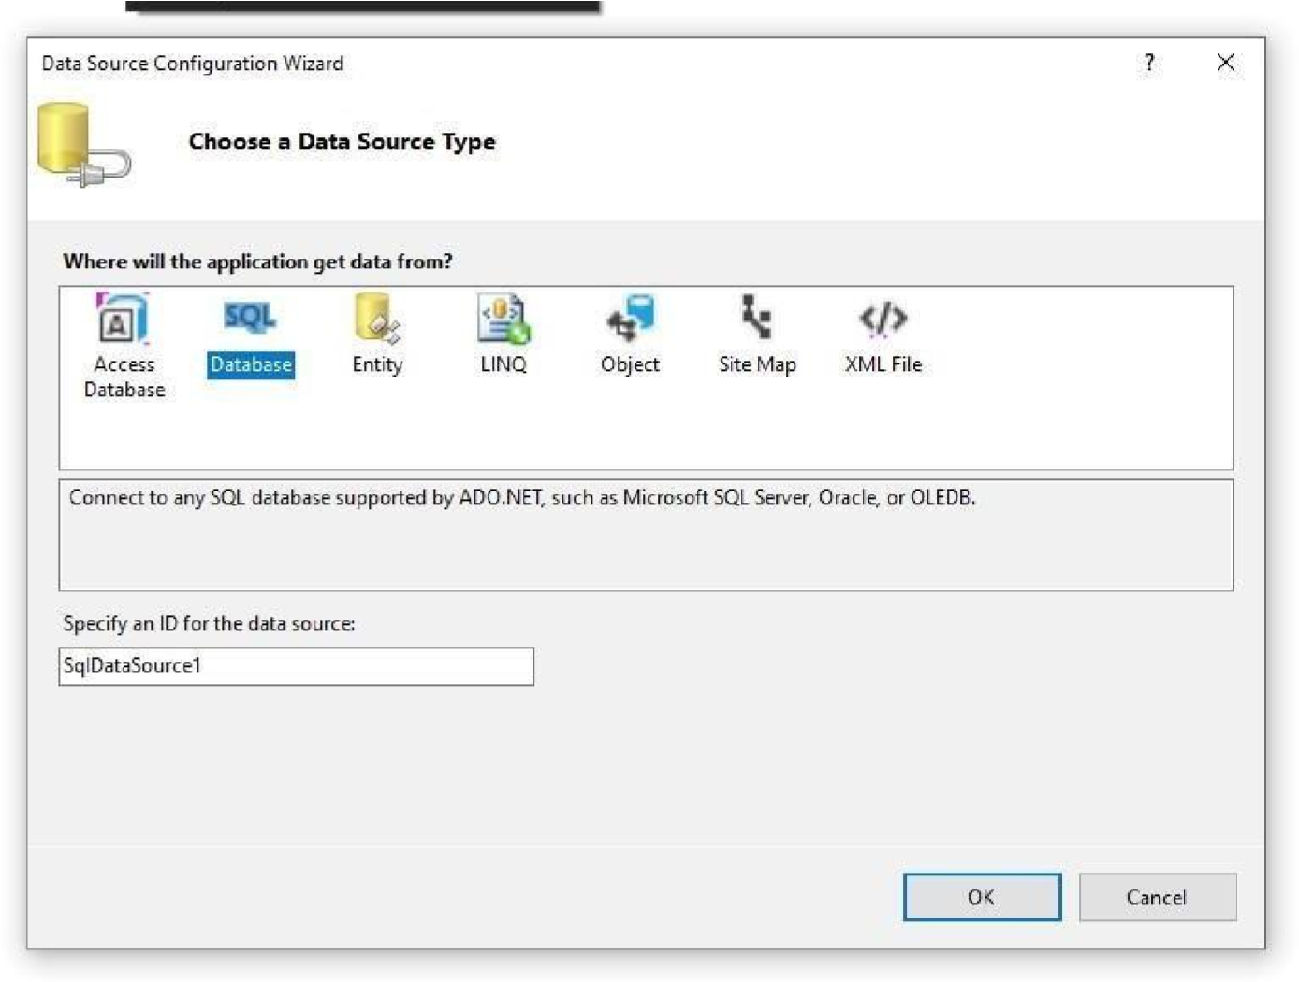

**Testing Connection**

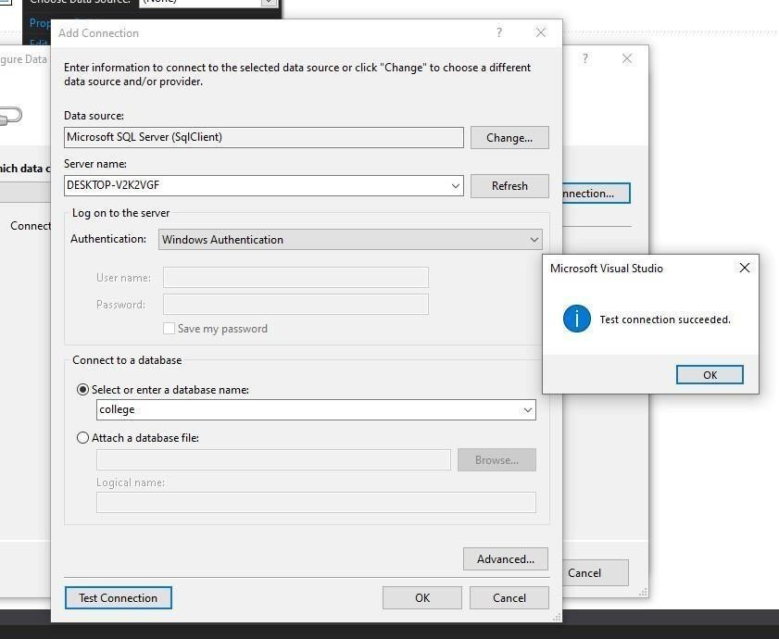

**Saving Connection**

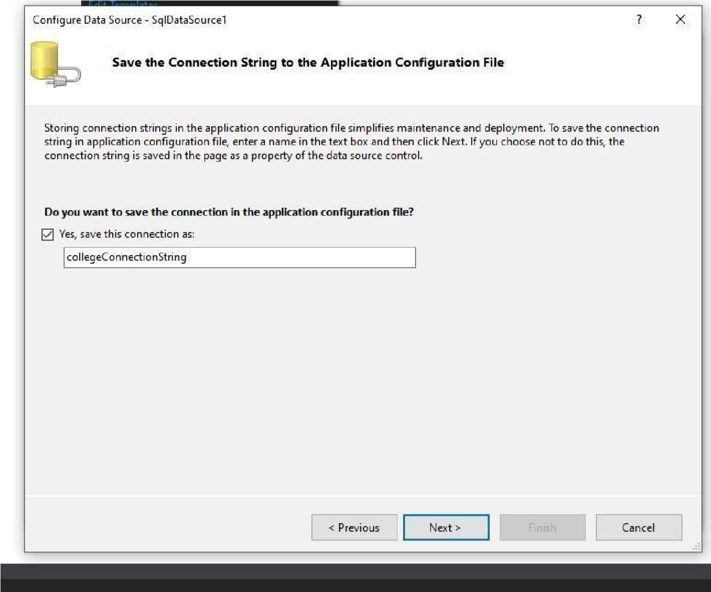

**Selecting Table**

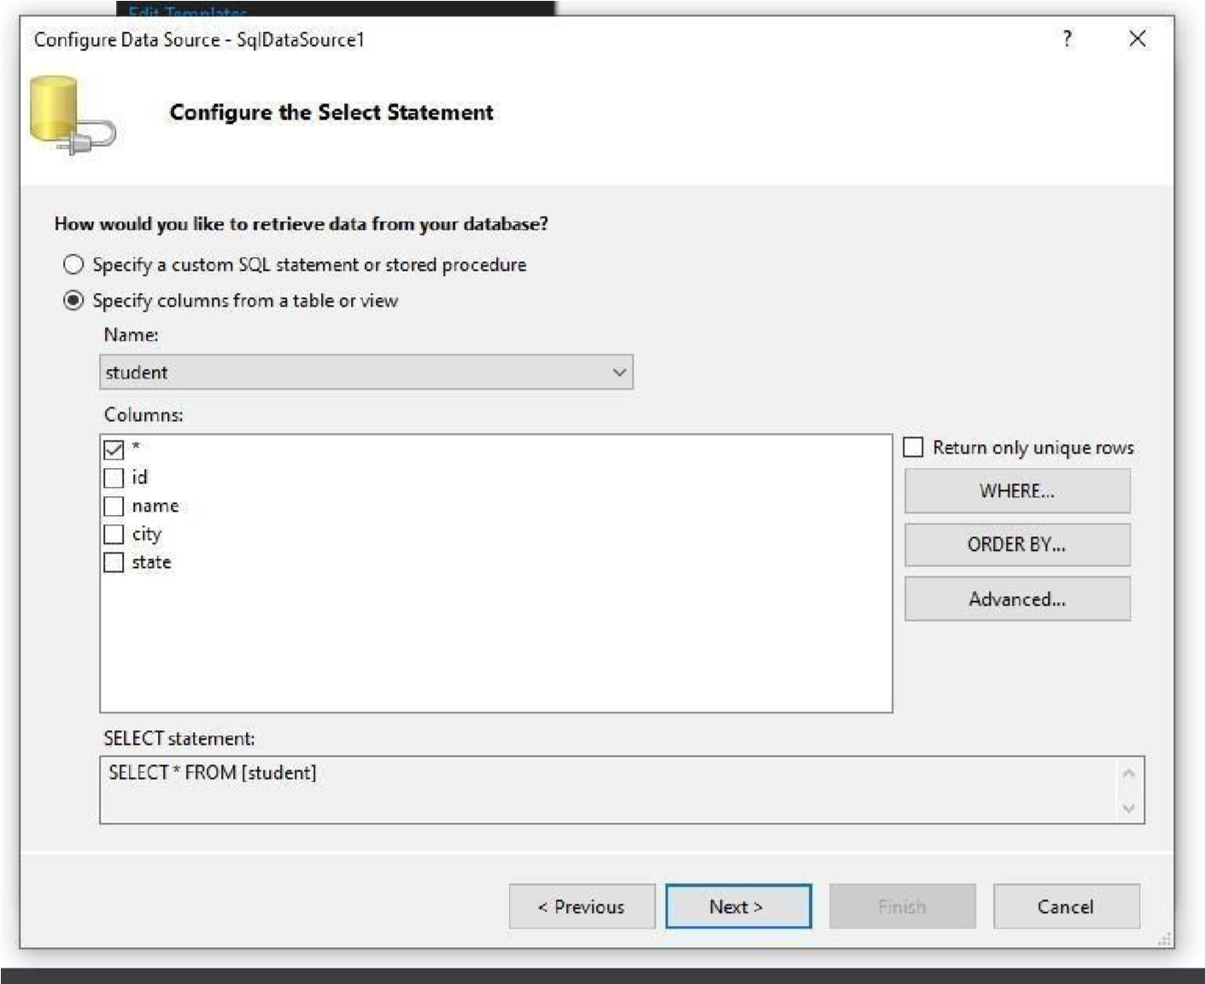

**Testing Query**

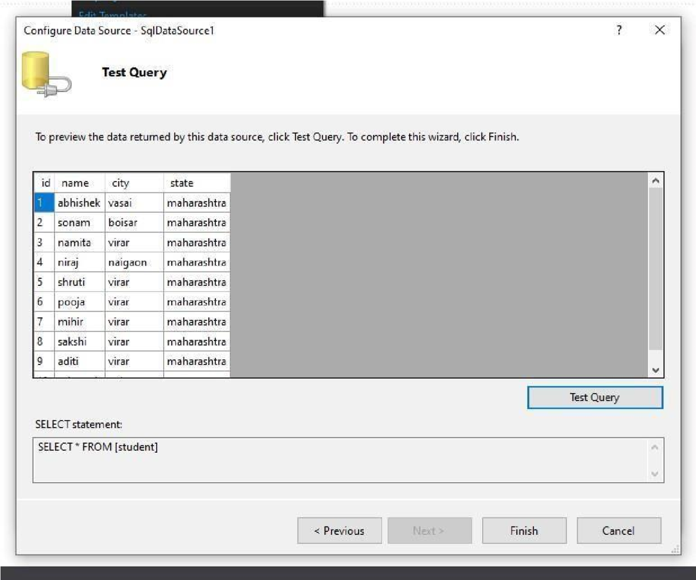

**WebForm.aspx**

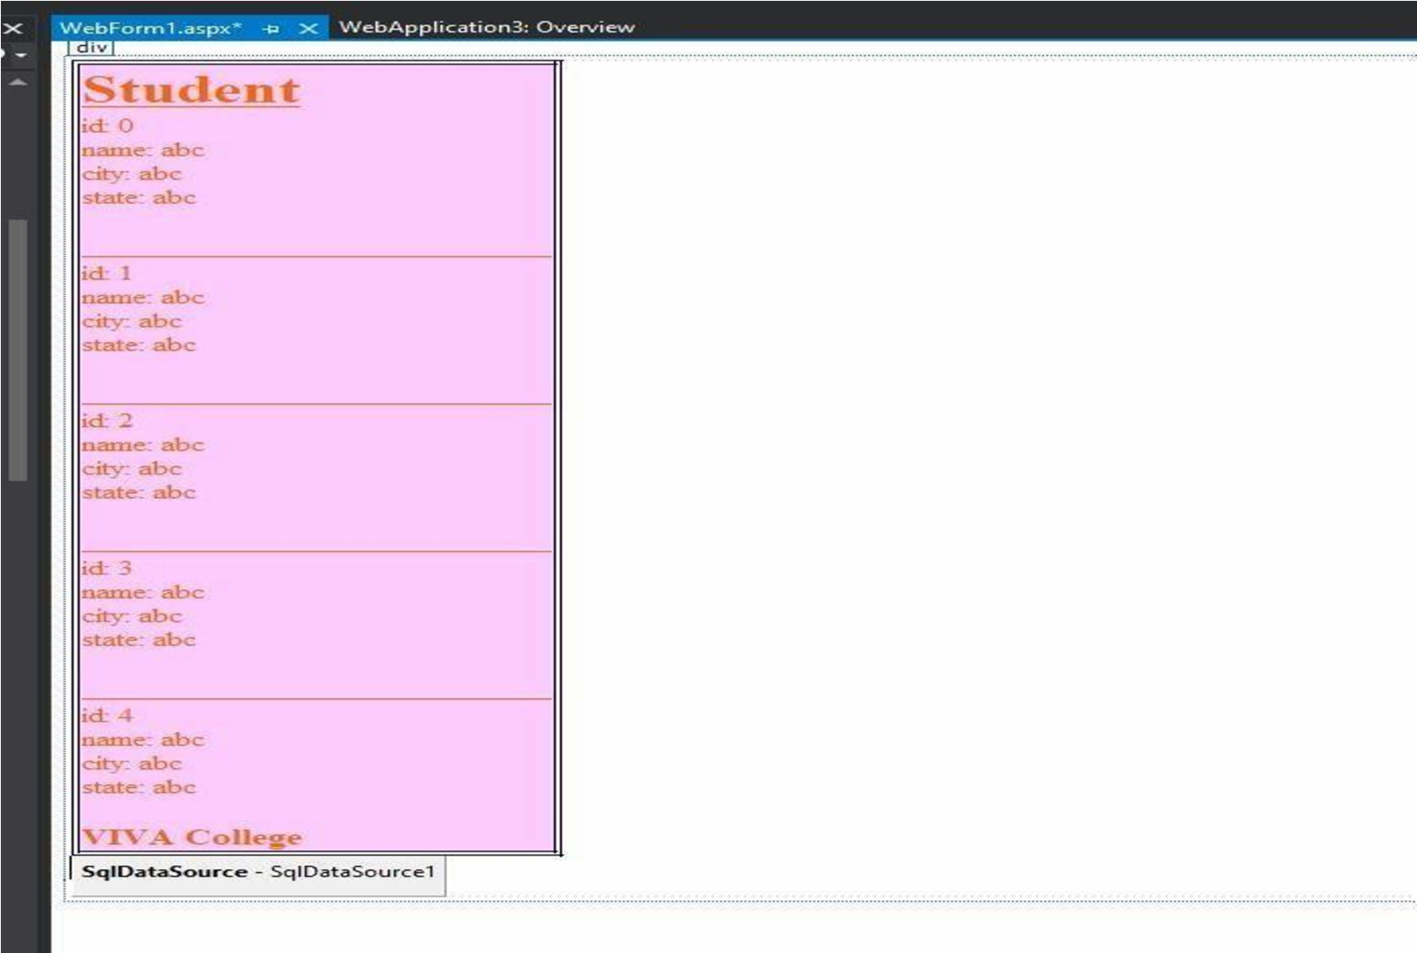

**Output :-**

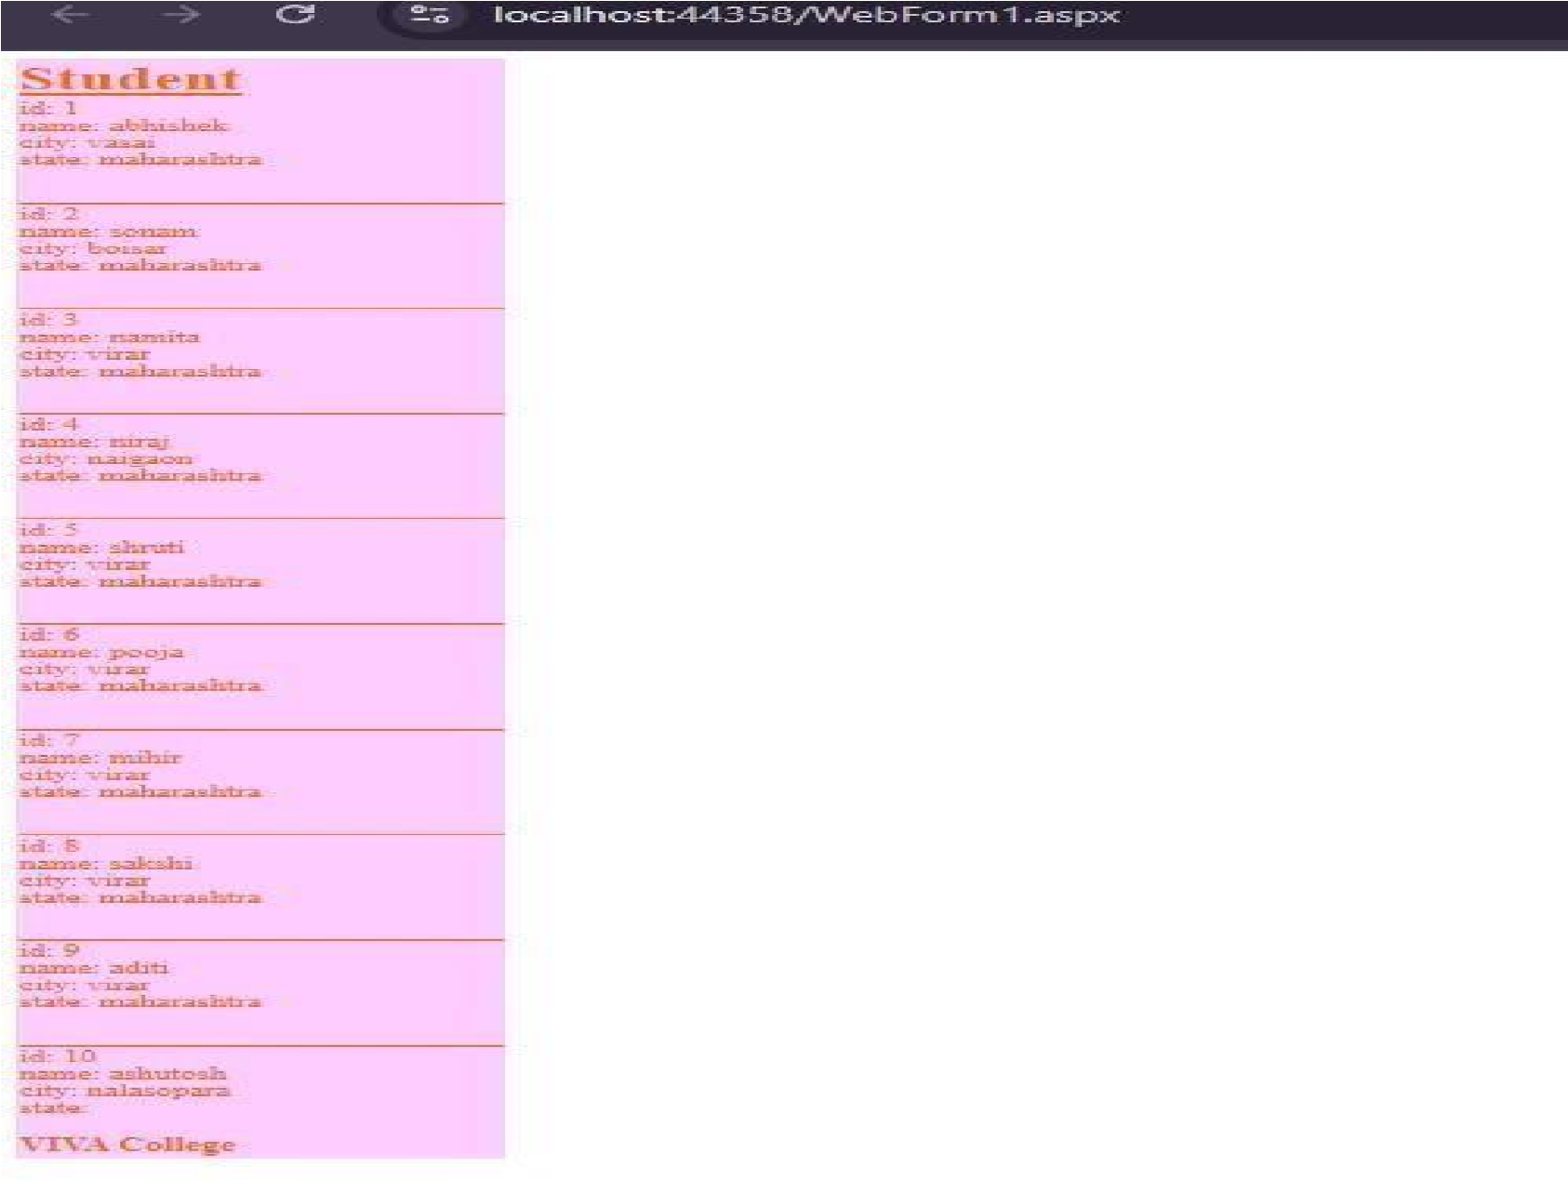

# 7b) Aim :- Displaying phone number, author name using author name.

**dbo.Student1**

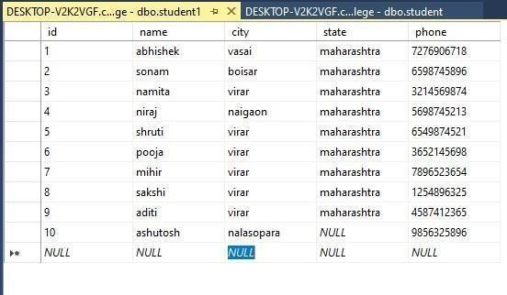

**Webform.aspx**

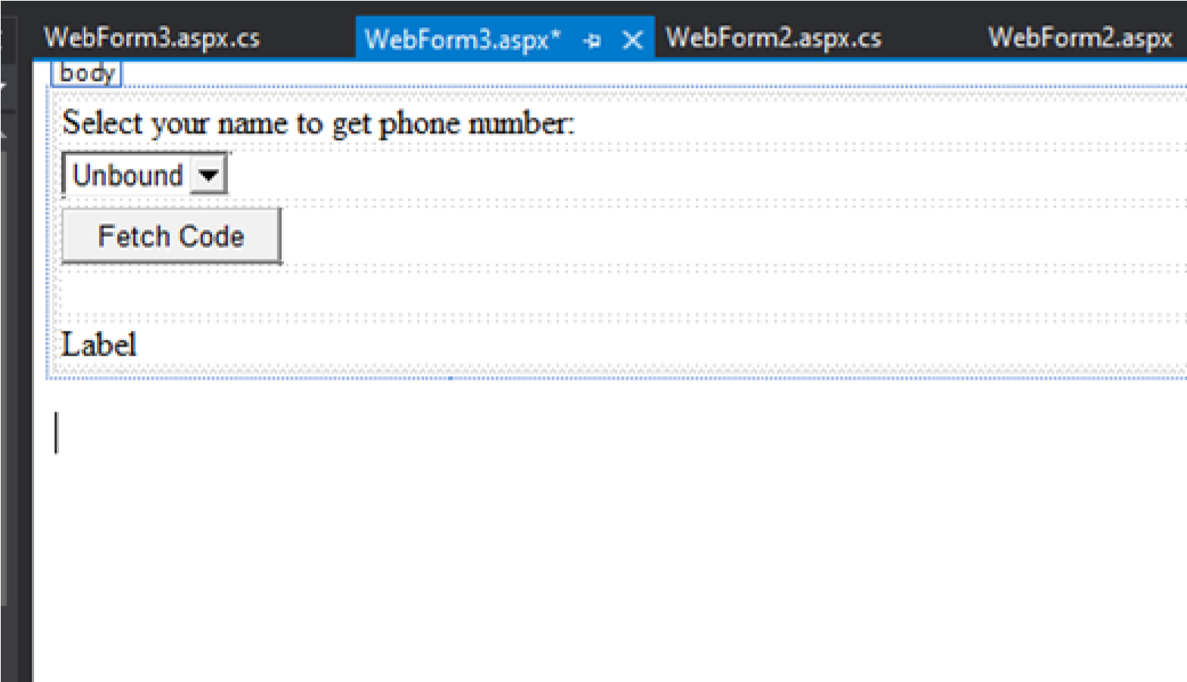

**Connecting to Sql Database**

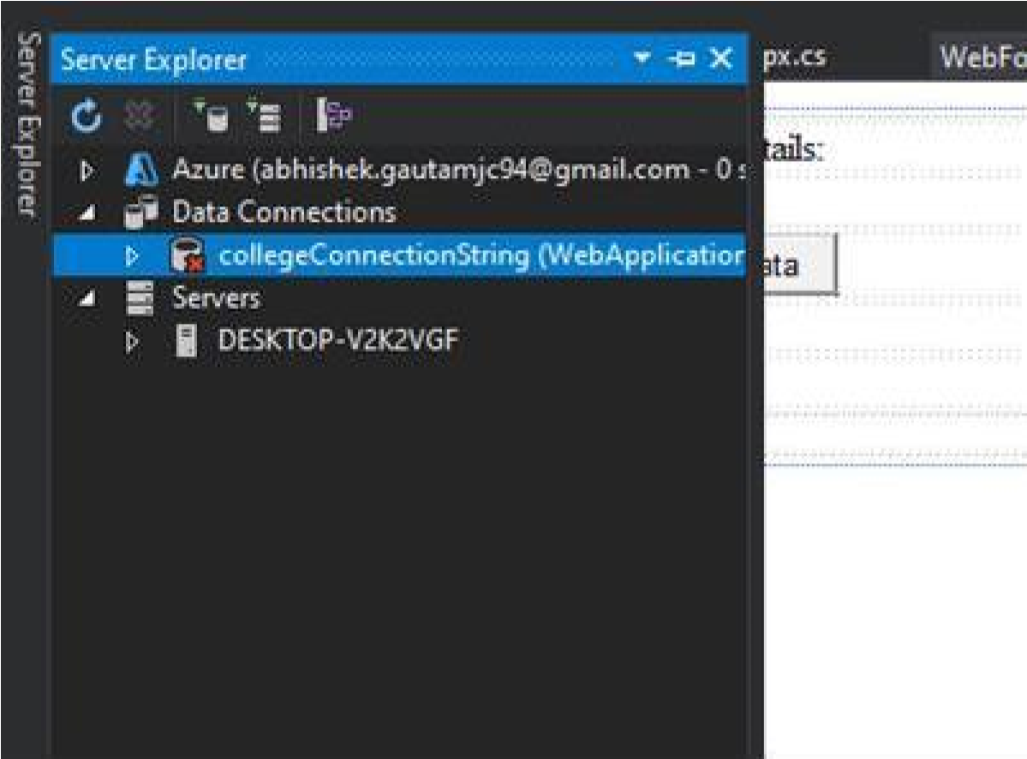

**Testing Connection**



**Webform.aspx.cs** using System;

using System.Collections.Generic; usingSystem.Data; using System.Data.SqlClient; using System.Linq;

using System.Web; using System.Web.UI; using System.Web.UI.WebControls; namespace WebApplication3

{ public partial class WebForm3 : System.Web.UI.Page

{ protected void Page_Load(object sender, EventArgs e)

{

SqlConnection conString = new SqlConnection("Data

Source=DESKTOP-V2K2VGF;Initial Catalog=college;Integrated Security=True");

conString.Open();

SqlCommand cmdQuery = new SqlCommand("Select * from student1",conString);

SqlDataAdapter sda = new SqlDataAdapter(cmdQuery); DataSet dsData = new DataSet(); sda.Fill(dsData);

DropDownList1.DataSource = dsData;

DropDownList1.DataTextField = "name";

DropDownList1.DataValueField = "Phone";

DropDownList1.DataBind();

} protected void Button1_Click(object sender, EventArgs e)

{

Label1.Text = "You have Selected " + DropDownList1.SelectedValue;

}

}

}

**Output :-**

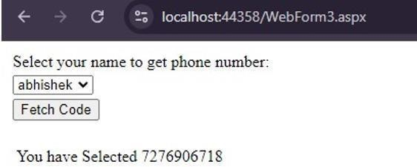

# Practical no. 08

# 8a) Aim :- Create a web application to demonstrate use of GridView

**dbo.student2**

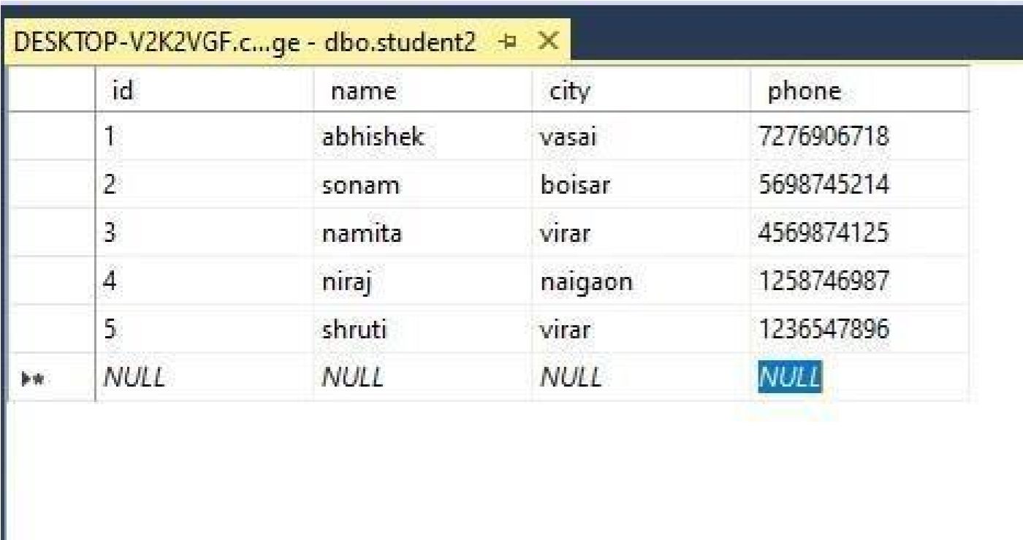

**WebForm.aspx**

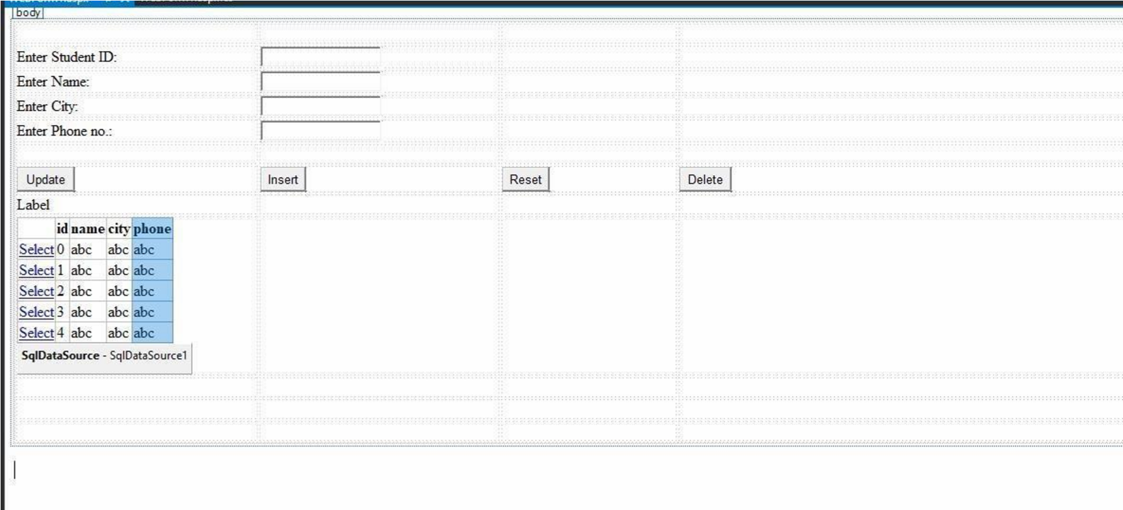

**Connecting**

**GridView**

**to**

**Sql**

**Database**

**Testing**

**Connection**

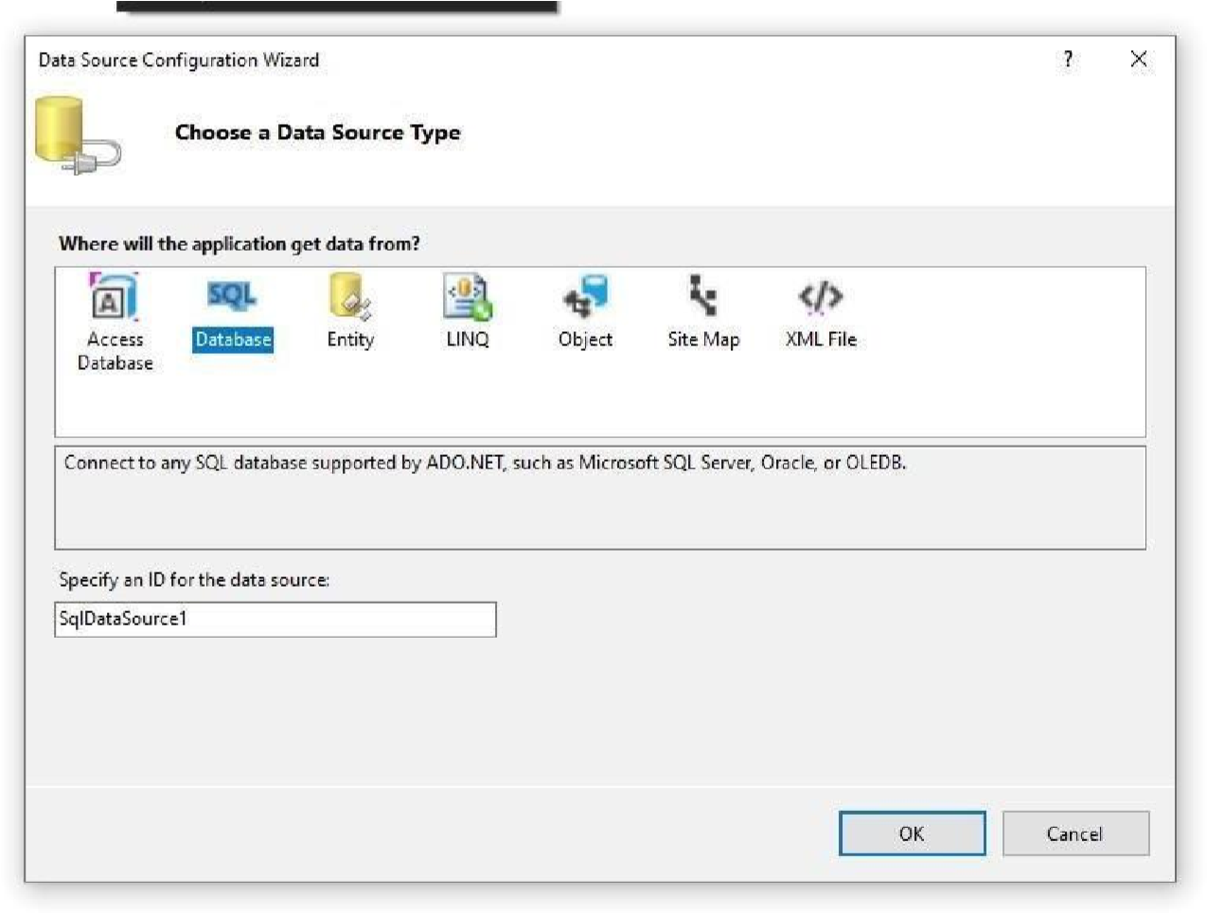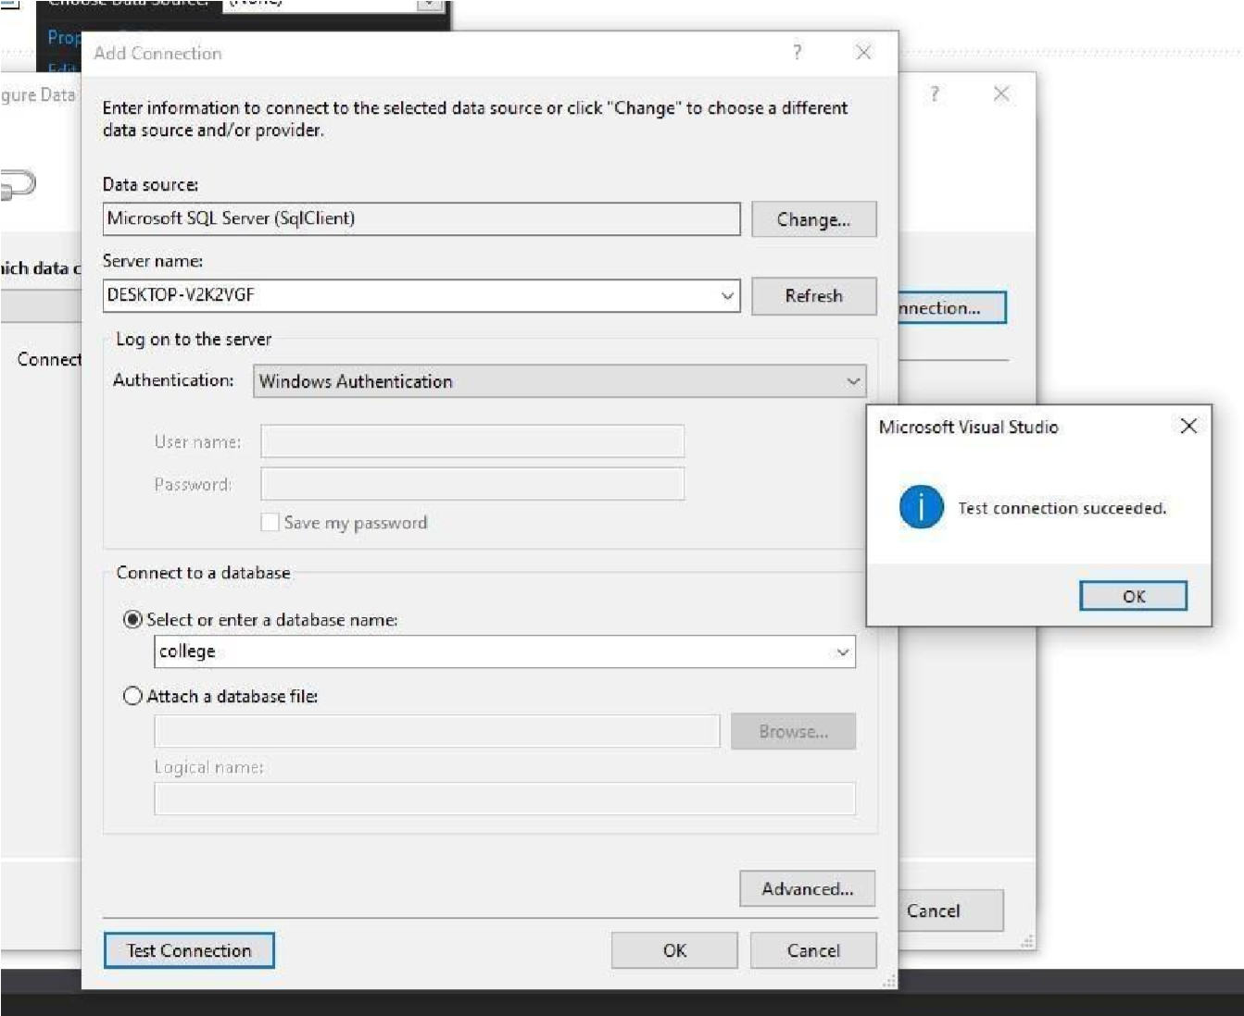

**Saving Connection**

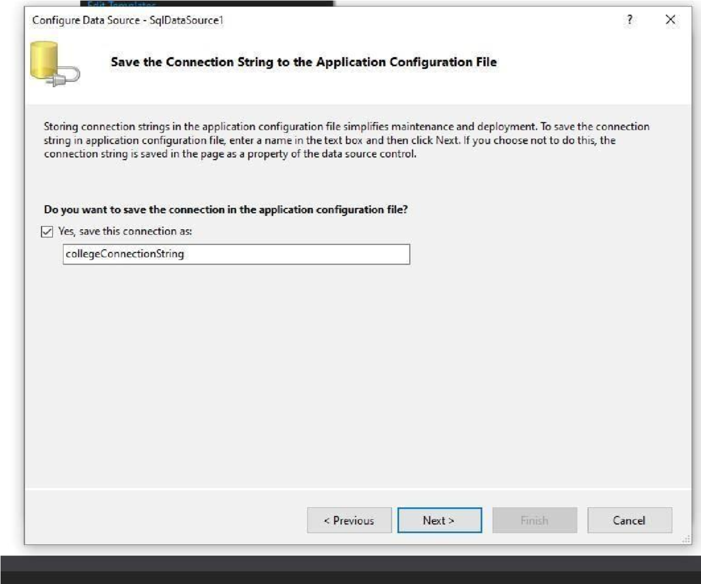

**Selecting Table**

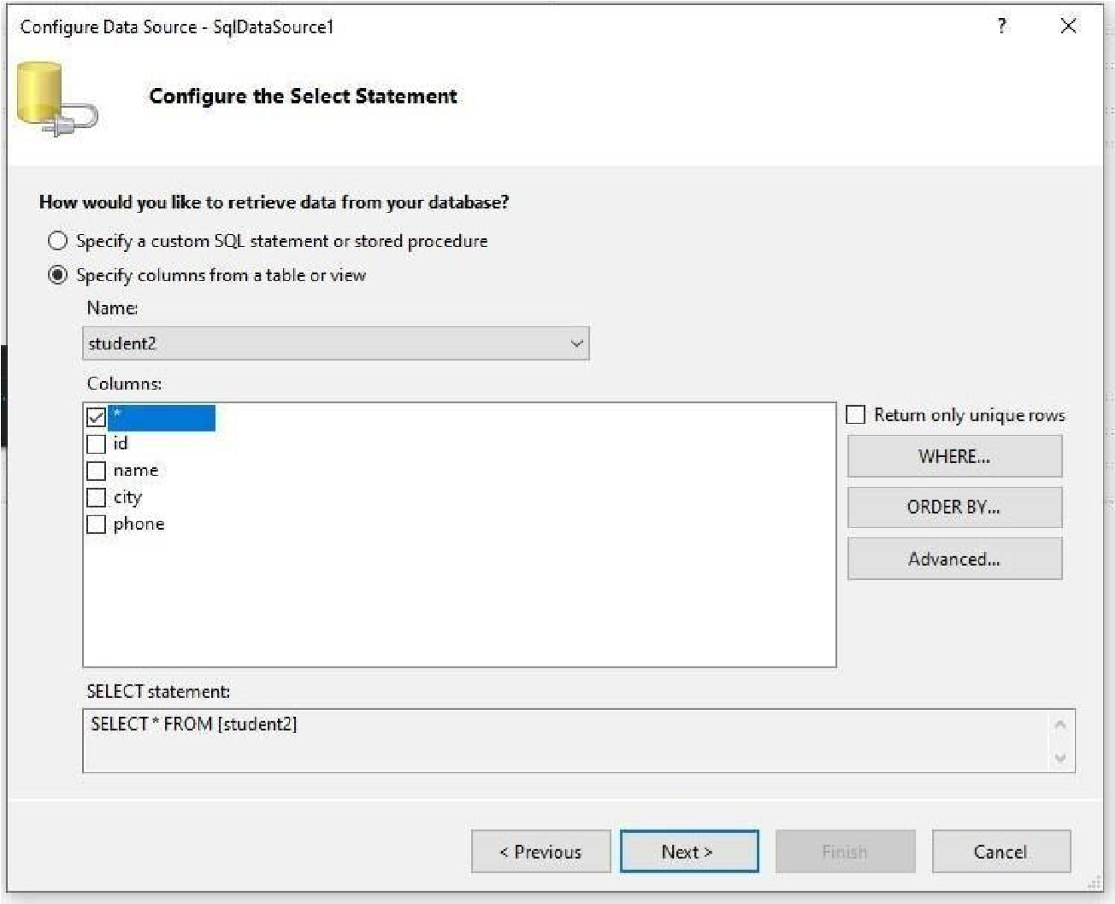

**Testing Query**

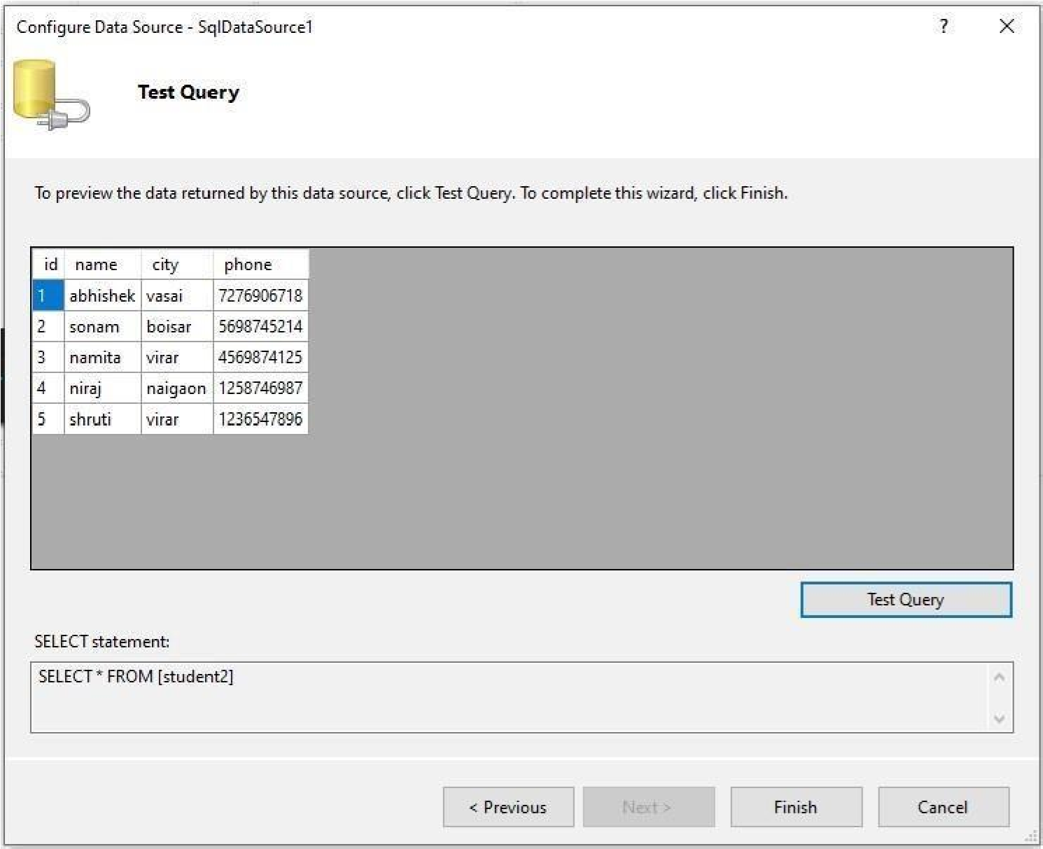

**WebForm.aspx.cs**

using System;

using System.Collections.Generic; using System.Data.SqlClient; using System.Linq; using System.Web; using System.Web.UI; using System.Web.UI.WebControls;

namespace WebApplication4

{ public partial class WebForm1 : System.Web.UI.Page

{ protected void Page_Load(object sender, EventArgs e) { }

protected void Button1_Click(object sender, EventArgs e)

{

SqlConnection conn = new SqlConnection("Data

Source=DESKTOP-V2K2VGF;Initial Catalog=college;Integrated Security=True");

conn.Open();

SqlCommand cmd = new SqlCommand("update student1 set name =

@name, city = @city, phone = @phone where id = @id", conn);

cmd.Parameters.AddWithValue("@id",TextBox1.Text); cmd.Parameters.AddWithValue("@name",TextBox2.Text); cmd.Parameters.AddWithValue("@city",TextBox3.Text); cmd.Parameters.AddWithValue("@phone", TextBox4.Text); cmd.ExecuteNonQuery();

} protected void Button2_Click(object sender, EventArgs e)

{

SqlConnection conn = new SqlConnection("Data

Source=DESKTOP-V2K2VGF;Initial Catalog=college;Integrated Security=True");

conn.Open();

SqlCommand cmd = new SqlCommand("insert into student1 values(@id,

@name, @city, @phone)", conn);

cmd.Parameters.AddWithValue("@id", TextBox1.Text); cmd.Parameters.AddWithValue("@name", TextBox2.Text); cmd.Parameters.AddWithValue("@city", TextBox3.Text); cmd.Parameters.AddWithValue("@phone", TextBox4.Text); cmd.ExecuteNonQuery();

Label1.Text = "entry successful."; conn.Close(); } protected void Button3_Click(object sender, EventArgs e)

{

TextBox1.Text = ""; TextBox2.Text = "";

TextBox3.Text = "";

TextBox4.Text = "";

} protected void Button4_Click(object sender, EventArgs e)

{

SqlConnection conn = new SqlConnection("Data

Source=DESKTOP-V2K2VGF;Initial Catalog=college;Integrated Security=True");

conn.Open();

SqlCommand cmd = new SqlCommand("delete from student1 where id=@id", conn); cmd.Parameters.AddWithValue("@id",TextBox1.Text); cmd.ExecuteNonQuery();

Label1.Text = "deletion successful."; conn.Close();

} protected void SqlDataSource1_Selecting(object sender, SqlDataSourceSelectingEventArgs e)

{

}

protected void GridView1_SelectedIndexChanged(object sender, EventArgs e)

{

TextBox1.Text = GridView1.SelectedRow.Cells[1].Text; TextBox2.Text = GridView1.SelectedRow.Cells[2].Text;

TextBox3.Text = GridView1.SelectedRow.Cells[3].Text;

TextBox4.Text = GridView1.SelectedRow.Cells[4].Text;

}

}

}

**Output :-**

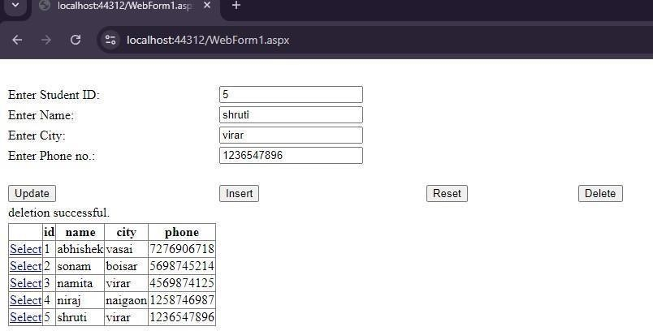

# Practical no. 09

# 9a) Aim :- Create a web application to demonstrate use of various Ajax controls.

**WebForm11.aspx**

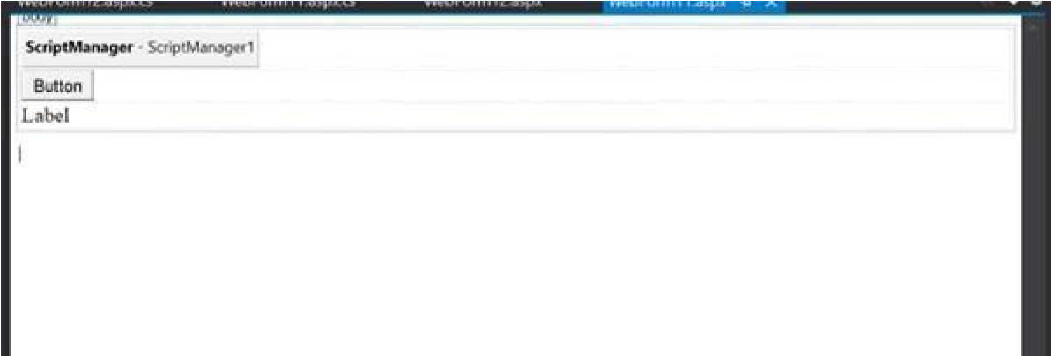

**WebForm11.aspx.cs**

using System; using System.Collections.Generic; using System.Linq; using System.Web; using System.Web.UI; usingSystem.Web.UI.WebControls;

namespace WebApplication6

{ public partial class WebForm11 : System.Web.UI.Page

{ protected void Page_Load(object sender, EventArgs e)

{

} protected void Button1_Click(object sender, EventArgs e)

{

Label1.Text = System.DateTime.Now.ToString();

}

}

}

**Output :-**

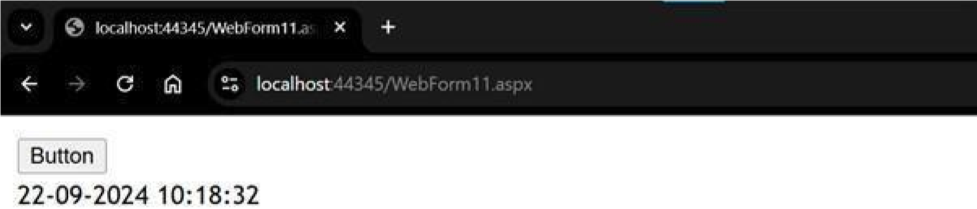

**WebForm12.aspx**

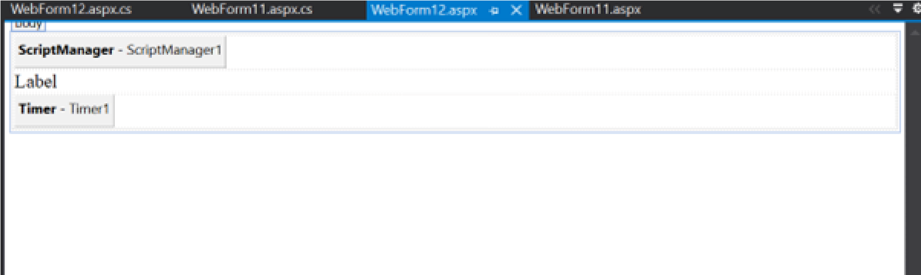

**WebForm12.aspx.cs**

using System;

using System.Collections.Generic; using System.Linq; using System.Web; using System.Web.UI; using System.Web.UI.WebControls; namespace WebApplication6

{ public partial class WebForm12 : System.Web.UI.Page

{ protected void Page_Load(object sender, EventArgs e)

{

} protected void Timer1_Tick(object sender, EventArgs e)

{

Label1.Text = System.DateTime.Now.ToString();

}

}

}

**Output :-**

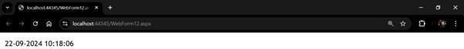

# Practical no. 10

# 10a) Aim :- Create a web application to demonstrate JS Bootstrap Button.

**boot.aspx**

<%@ Page Language="C#" AutoEventWireup="true" CodeBehind="boot.aspx.cs"

Inherits="bootstrap.boot" %>

<!DOCTYPE html>

<html xmlns="[http://www.w3.org/1999/xhtml">](http://www.w3.org/1999/xhtml)

<head runat="server">

<title></title>

<script type="text/javascript" src="https://cdnjs.cloudflare.com/ajax/libs/jquery/3.7.1/jquery.min.js">

</script>

<link rel="stylesheet" href="https://cdnjs.cloudflare.com/ajax/libs/twitterbootstrap/3.0.3/css/bootstrap.min.css" media="screen" />

<script type="text/javascript" src="https://cdnjs.cloudflare.com/ajax/libs/twitterbootstrap/3.0.3/js/bootstrap.min.js"> </script>

</head>

<body>

<button type="button" class="btn btn-info btn-lg" data-toggle="modal" data-target="#myModal">Open

Modal</button>

<div id="myModal" class="modal fade" role="dialog">

<div class="modal-dialog">

<div class="modal-content">

<div class="modal-header">

<button type="button" class="close" data-dismiss="modal">&times;</button>

<h4 class="modal-title">Hi this is my first modal</h4>

</div>

<div class="modal-body">

<p>Bootstrap is the Best...!</p>

</div>

<div class="modal-footer">

<button type="button" class="btn btn-default" data-dismiss="modal">Close</button>

</div>

</div>

</div>

</div>

</body>

</html>

**Output :-**

